Annual Pupil Transportation Report
Instructions

Table of Contents
(All Lines are Hyperlinks)

General Overview 2
Completion Procedures 3
Completion Date 4
Required Signatures 4
Sending Correspondence 4
Bus Data Input 4 - 6
Bus Data 4
Surplus Property 6
State Surplus Contracts 6
Expenditures
Reporting Local Expenditures Memorandum 7 - 8
Expenditures – General Information 9
Expenditures (Local) – Data Entry 10 - 12
Bus Drivers 10
Transportation Personnel 11
Other Local Expenditures 11 - 12
Inventory
Inventory – Data Entry Overview 13 - 14
Oil and Lubricants 15 - 29
Quick Computation Reference 15
- Beginning 16
- Purchased 17 - 18
- Used 19 - 20
- Ending (Actual) 21 - 22
- Adjustments (Additions) 23 - 24
- Adjustments (Deletions) 25 - 26
- Transferred to/from another LEA 27 - 28
- Removed Obsolete/Damaged Inventory 29

Tires Quantity (New & Recaps) 30 – 45
Quick Computation Reference 30
- Beginning 31
- Purchased 32 - 33
- Used 34 - 35
- Ending (Actual) 36 - 37
- Adjustments (Additions) 38 - 39
- Adjustments (Deletions) 40 - 41
- Transferred to/from another LEA 42 - 43
- Removed Obsolete/Damaged Inventory 44 - 45
Tire Value (All) 46 - 60
Quick Computation Reference 46
- Beginning 47
- Purchased 48 - 49
- Used 50 - 51
- Ending (Actual) 52 - 54
- Adjustments (Additions) 54 - 55
- Adjustments (Deletions) 56 - 57
- Transferred to/from another LEA 58 - 59
- Removed Obsolete/Damaged Inventory 60
Stocked Inventory-Repair Parts Value 61 - 80
Quick Computation Reference 61
- Beginning 62
- Purchased 63 - 65
- Used 66 - 68
- Ending (Actual) 69 - 70
- Adjustments (Additions) 71 - 73
- Adjustments (Deletions) 74 - 76
- Transferred to/from another LEA 77 - 79
- Removed Obsolete/Damaged Inventory 80
Diesel – Quantity &Value 81 - 94
Quick Computation Reference 81
- Beginning 82
- Purchased 83 - 84
- Used 85 - 86
- Ending (Actual) 87 - 88
- Adjustments (Additions) 89 - 90
- Adjustments (Deletions) 91 - 92
- Transferred to/from another LEA 93
- Removed Obsolete/Damaged Inventory 94
Unleaded – Quantity &Value 95 - 106
Quick Computation Reference 95
- Beginning 96
- Purchased 97 - 98
- Used 99 - 100
- Ending (Actual) 101 - 102
- Adjustments (Additions) 103
- Adjustments (Deletions) 104
- Transferred to/from another LEA 105
- Removed Obsolete/Damaged Inventory 106
Other Fuels & DEF - Value 107 - 123
Quick Computation Reference 107
- Beginning 108
- Purchased 109 - 111
- Used 112 - 114
- Ending (Actual) 115 - 116
- Adjustments (Additions) 117 - 118
- Adjustments (Deletions) 119 - 120
- Transferred to/from another LEA 121 -122
- Removed Obsolete/Damaged Inventory 123
Non-Stock Inventory
Non-Stock Inventory – Data Entry Overview 124
- Purchased & Used 125
Obsolete and Damaged Inventory
Obsolete and Damaged Inventory 126 - 127
- Obsolete and Damaged Inventory – Data Entry 126 - 127
Buster Report
- Buster Report – Data Entry 128

Overview

- DPI (Department of Public Instruction) strongly advocates that individual(s) delegated to complete the TD-1 Annual Report read all the directions cautiously before recording any information to the report.

It is mandatory all administrative units complete the questionnaire located on the Bus Data Tab.

- City units must be separate from county units.

Assistance references helpful in completing the TD-1 Annual Report:
- Definition of Transportation Terms
- Annual State Funds Transportation Expenditures (503 Data)
- Annual Local Funds Transportation Expenditures Reports (PRC 056 & 706)
- Time Sensitive - ZMB19 End-of-the-Year Inventory 2019 & 2020
(Quantity and Values)
- MCIS Annual Cost/Consumption Report (July-June)
- MCIS Annual Miles Report (July-June)
- ZMB20 - Various material reports on purchases,
- material usage and adjustments
- Motor Fleet Mgt. Vehicle File Folder
- Other County Vehicle File Folder
- Inventory Sold to Other Counties File Folder
- Refund Reports TD-19 (July-June)
- Summer School Mileage & Costs Data
- Other Special Program Mileage & Costs Data
- Refund Rates for Special Programs Bus Use
Completion Procedures

Completion Date:
Postmarked before on or before July 31st, 2020

Required Signatures:

Before postal sending the TD-1 correspondence to DPI (Department of Public Instruction) please verify that all corresponding parties have authorized by signing:

- Cost Clerk
- Transportation Director
- Finance Officer
- School Superintendent

Sending Correspondence:

Send by both methods:

- Electronic mail: (Excel file format – DO NOT send as PDF)

Email to Mr. CS Wright; Stephen.Wright@dpi.nc.gov

- Postal mail (Printed and Signed copy)

Kevin Harrison, Section Chief
N. C. Department of Public Instruction
Division of School Support/Transportation
N. C. Education Building
6319 Mail service Center
Raleigh, N. C. 27699-6319
Bus Data Input

Data Input:
LEA Name LEA name is selected from the field’s drop-down list.
LEA Number LEA number automatically generates based upon LEA name chosen.

Bus Data
- Days Operated
The number of days the entire fleet operated for the traditional school term.

- The value entered should not exceed 185 days.

- Bus Mileage
Total miles operated for the school year for all regular and spare buses.
- Expended for non-exceptional children student(s).
- Expended for exceptional children student(s).

- Detail Data
Break the totals input for line items B1 and B2 down by the following
- Total regular school mileage for regular buses.
- Total regular school mileage for exceptional child buses.
- Refunded mileage (includes from all sources to PRC 56).

- Service Vehicles
Record the total annual miles for all state funded service vehicles.

- Buses Operated
Record the number of buses.
- Regular that operated daily (Assigned to routes and used for non-EC students)

- Do NOT include spare buses.

- Exceptional Children buses that operated daily.
- NERS (Northeast Regional School of Biotechnology and Agri science) buses that operated.

- Line three ONLY applies to the LEAs of:
- Beaufort
- Martin
- Pitt
- Tyrrell
- Washington.

- Summer School
Input the number of buses operated for summer school.

- Bus Communication Devices
Record the number of buses with
  - Equipped with two-way radios.

- Include radios that are purchased, but not installed in the total count.

  - Equipped with cell phones.

- Include cell phones that are purchased, but not installed in the total count.

- Bus Recording Devices
Record the number of buses with
- Safety assistant/monitor(s) onboard
- Analog Camera System (Recording to Tape)
- Interior Digital Camera Systems

- If entries are made on lines a through d; use the drop-down menu to select a primary vendor. If secondary vendor applicable; make that selection as well.
    - One camera
    - Two cameras
    - Three cameras
    - Four or more cameras

- Exterior Stop Arm Cameras

- If an entry is made on lines four; use the drop-down menu to select a primary vendor. If secondary vendor applicable; make that selection as well.

- Bus GPS/Automatic Vehicle Location Systems
Record the number of buses with
- Real time
- Passive

- Time Card Systems
Record the number of buses with ETC (Electronic Time Card) Systems
Surplus Property
Record the number of
- Surplus school buses sold (include line "C")
- Surplus state service vehicles sold
- Pounds scrap metal sold

State Surplus Contracts
Record the number of
- Scrap tires sold
- Gallons of used oil recycled
- Gallons of used anti-freeze recycled
- Gallons of bio-diesel purchased
- Pounds of scrap metal sold
Reporting Local Expenditures - Memorandum

28-Sep-04
MEMORANDUM

TO: LEA Superintendents, Finance Officers, and
Transportation Directors

FROM: Philip Price, Associate Superintendent
Financial and Business Services

Derek Graham, Section Chief
Transportation Services

SUBJECT: Reporting Local Transportation Expenditures

In an effort to more accurately report local transportation expenses, two changes to the Uniform implemented effective July 1, 2004.

- PRC 056 in Fund 2 is designated to record all Eligible local transportation expenditures. The available account codes for Fund 2, PRC 056 will be the same as the Fund 1, PRC 056 account codes.

- PRC 706 in Fund 2 is being designated to record Other / Ineligible local transportation expenditures.

ELIGIBLE EXPENDITURES
Eligible local expenditures are those expenditures that local boards of education provide to supplement the operation of the yellow school bus fleet. They are "eligible" to be included in the state transportation funding formula. These local expenditures are restricted o the basic “to-and from-school” transportation for K-12 students for their regular school term and restricted or limited to those costs that are applicable to the existing PRC 056 account codes set forth in the current state uniform chart of accounts. These expenditures include transportation personal and driver supplements, shop and office supplies, utilities costs, communication cost, etc. (See – PRC 056 Chart of Accounts).

INELIGIBLE EXPENDITURES
Other local transportation expenditures should be paid from Program Report Code (PRC) 706 or other state, federal local PRC and not PRC 056. Ineligible local expenditures include, but are not limited to the following:

- SALARIES
- Transportation safety assistants or monitors salaries.
- Driver incentive or bonus pay (e.g., perfect attendance, safe driving record, etc.)
- Transportation Director’s salary.
- That portion of split-funded personnel salary cost that is not transportation related.
- Salary Differential Pay (Additional payments above State Salary Schedule amount).
- Transportation employees assigned to maintain or schedule local vehicles.
- Driver salary for routes serving only local pre-k programs, Head Start, Summer School, Pre-K EC programs.
- Summer Interns.

- BENEFITS
- Insurance Benefits other than Social Security, Retirement and Hospitalization.
- Longevity Pay.

- SUPPORT
- Capital purchases or improvements.
- Field trips.
- Employee’s CDL Costs/Reimbursement.
- Utilities for facilities that are not separately metered.
- Banquet Costs.
- Drug-Testing Program for employees other than yellow bus drivers and transportation staff.
- Costs associated with transportation services provided for at-risk programs (state, local or federal).
- Mileage costs to reimburse state for yellow bus use.
- Costs for transportation purchases that are state reimbursed through contingency funding.
- Costs for bus driver or transportation personnel physical exams.

- VEHICLES
- Purchase of Vehicles.
- Purchase of Activity Buses
- Maintenance and operation of activity buses and all other local vehicles.
- Costs associated with Driver Education Program vehicles.

We anticipate that the implementation of these changes should also expedite the completion of the "TD-1 Annual Pupil Transportation Report".

If you have any questions about these account code and procedure changes, please contact DPI "Information Analysis and Reporting."

If you have questions concerning eligible or ineligible expenditures, please contact Steve Beachum or Derek Graham at DPI Transportation Services (919) 807-3570.
Expenditures – General Information

State expenditures used in the allotment formula will be accounted for through the State Public School Fund for PRC 056. The local expenditures that you report in the next three sections of this report represent funds that the local board of education provides to supplement the operation of the yellow school bus fleet (i.e., driver and personnel supplements, shop supplies, utilities, etc.).

These local expenditures are restricted to basic "to-and-from-school" transportation for K-12 students for the regular school term. These expenditures should be accounted for through your Local PRC 056 - Fund 2. Please have the chief financial officer at each respective LEA certify these stipulations regarding the local funds documented on this report.

Local expenditures for the following are excluded or restricted:
- See "Reporting Local Expenditures"

- Use of the yellow buses for which the state transportation budget was reimbursed
- Capital purchases or improvements
- Driver incentive or bonus pay
- Transportation safety assistants or monitors
- "Other Expenditures" are restricted to those costs that are applicable to the existing object codes in State PRC 056

- Report all dollar amounts to the nearest whole dollar.

Local Expenditures – Data Entry

Finance Officer Certification
Two sections on the report require that the Finance Officer verify the information input and requires the Finance Officer to input his/her initials to signify that verification.

Bus Drivers – Local Expenditures
- Driver Salary
Input the value of local funds that were expended to provide driver salaries; including any pay supplement. The salary supplement must apply to all drivers and be paid regularly (i.e., hourly, daily, monthly) in addition to the driver's state pay.

- This salary is not associated with any incentive or bonus plan.

- Driver Incentives
Record the sum of local funds that were expended to provide drivers incentive pay or performance bonuses. This payment could be monthly, semi-annual, or annual. Incentive pay is not paid to all drivers but rather to those drivers who have achieved some predetermined goal such as perfect attendance or an accident-free driving record.

- Although you are reporting this amount, this local pay will not be included in the allotment formula process.

- Compensation Exceeding $17.45 per hour
Using the total payment (state salary and local supplements from number A above) each driver received for the year and the total hours worked for the year, please determine if any drivers were paid more than the maximum allowable cost per hour under the state salary schedule for drivers (See worksheet for Line C2 on Local Expenditures of TD-1 Excel file).

- The total compensation should be based on regular pay. Do not include any overtime pay in the calculation.

- Input the number of individuals that earned more than state salary schedule.
- If any drivers did receive average compensation more than the maximum per hour allowed, please record the total excess amount for all drivers.

Automatic Computation
This line represents the "net" total; the actual local funds for driver salaries used in the allotment formula process.
- Driver Matching Benefits
Input the matching benefits for drivers applicable to the salary amounts in lines A, B, and C.

Transportation Personnel

- For line items A & B record results to the nearest half position.
- Administrative staff typically includes the director, supervisor, office staff, and any other non "wrench-turning" employees.

- State Paid Positions
- Input the number of administrative personnel on staff.
- Input the number of mechanics on staff.

- Local Paid Positions
- Input the number of administrative personnel on staff.
- Input the number of mechanics on staff.

- Personnel Salaries (Local funds)
- Director
Record the information as noted for the transportation director.

- If the director does not receive any salary from local funds, please indicate "none" by entering a zero in the Local Salary field.

- Other Personnel
Record information, as noted for all other transportation personnel receiving a salary from local funds.

- The salaries listed for this personnel must represent duties directly attributable to the day-to-day school bus operations.
- Additional entries can be made on the Local Expenditures (Continued) Worksheet. The Salaries and Match Benefits will automatically carry.

Other Local Expenditures

- Fuel
If local funds were used to purchase fuel to finish the regular school term, please indicate the amount expended.

- Contract Transportation
Record the amount of funds expended.

- There must be adequate TD 24A forms on file at DPI to support these local expenditures as well as the state funds spent on contract transportation per the State Public School Fund.

- Other Expenditures
If local funds were used in other areas to support the primary school bus operation, record these items and amounts.

- The items might include utilities, shop supplies, drug testing or any other cost that corresponds to the existing object codes in state PRC 056 and can be traced back to your local PRC 056 expenditure account.

- Costs that cannot be traced back to your local PRC 056 account will not be allowed.

  - Costs reported as "Miscellaneous or Other" will not be allowed
Inventory – Data Entry Overview

Time Sensitive Data

- Physical inventory is required to be completed by June 30, 2020.

- Line A – Beginning Inventory retrieve on the first working day of July 2020.
Otherwise, you must use the prior year’s TD-1; Line D – Ending Actual Inventory.

- Line D – Ending Actual Inventory retrieve on the last working day of June 2020 in the evening or the first working day of July 2020 before any work is input.

- Once you pull this data, NO fuel or parts documents should be backdated into June (Reference date on completion of a work order is still okay to backdate)
BSIP Transactions Utilities Required
- ZMB19 – Inventory query: IVBA
- ZMB20 – Transaction History Report

Icons Used in Transactions

- Multiple Selection icon
- Execute icon
- Total icon
- Exit icon

Finance Officer Certification
A section on the report requires that the Finance Officer verify the information was input prior to June 30 of present year and requires the Finance Officer to input his/her initials to signify that verification.

Summary Analysis
Overall Change in Stock Level (Line D - Line A):
This is to serve as information for you about how your overall stock level looks in each category.

Example: LEA had $100,000 of stock last year, $80,000 this year. Couple of options; first it might tell you that the budget was lean and you were running out of cash to make purchases, or it may indicate that the inventory manager is doing well and removing overstock items off the shelves.

- You should not look at this section until you have completed entering the data which calculates line H. Line H data comes from the Obsolete or Damaged Inventory worksheet.

Difference between the Listed number in Line D and what the other numbers indicate:
The purpose of this row is to show whether the numbers in the section above are consistent.
Beginning inventory, plus and minus usage should resemble the ending inventory – due to rounding they may be a little off. If this field is not near zero, then the various numbers need to be reviewed for correctness. The issue is typically caused by the following:

- Data Entry Error (Wrong value keyed, or pulled the wrong data)
- Changed the materials covered or were inconsistent between what materials were used in each line's information
- Having an invalid starting/ending inventory number (ending inventory number from last year) (didn't pull the report on the correct day)

Oil and Lubricants – (Charge Account code: 424)

- This procedure will not necessarily capture all the lubricants dispensed. However, please follow the instructions as defined.

Quick Computation Reference

 |  |  | Date |  | Material
Ln | Trans./Form | Col. | Range | Plant | Include | Exclude | Type | Total
A | TD-1 | -- | Prior Yr. | -- | -- | -- | -- | Line D
B | ZMB20 | Left | 07/01/2019 | 6### | 159000000 | 159000052 | 101 | Total Trans. Value
 |  | Right | 06/30/2020 |  | 159999999 | 159000062 | 199
 |  | Left |  |  |  | 159000098
 |  | Right |  |  |  | 159000099
C | ZMB20 | Left | 07/01/2019 | 6### | 159000000 | 159000052 | 261 | Total Trans. Value
 |  | Right | 06/30/2020 |  | 159999999 | 159000062 | 262
 |  | Left |  |  |  | 159000098
 |  | Right |  |  |  | 159000099
D | ZMB19 | Left | 12/2020 | 6### | 159000000 | 159000052 | -- | Total Value
 |  | Right | 12/2020 |  | 159999999 | 159000062
 |  | Left |  |  |  | 159000098
 |  | Right |  |  |  | 159000099
E | ZMB20 | Left | 07/01/2019 | 6### | 159000000 | 159000052 | 701 | Total Trans. Value
 |  | Right | 06/30/2020 |  | 159999999 | 159000062
 |  | Left |  |  |  | 159000098
 |  | Right |  |  |  | 159000099
F | ZMB20 | Left | 07/01/2019 | 6### | 159000000 | 159000052 | 702 | Total Trans. Value
 |  | Right | 06/30/2020 |  | 159999999 | 159000062
 |  | Left |  |  |  | 159000098
 |  | Right |  |  |  | 159000099
G | ZMB20 | Left | 07/01/2019 | 6### | 159000000 | 159000052 | 303 | Total Trans. Value
 |  | Right | 06/30/2020 |  | 159999999 | 159000062 | 304
 |  | Left |  |  |  | 159000098
 |  | Right |  |  |  | 159000099
H | Obsolete Inv | -- | -- | -- | -- | -- | -- | Automatic
 | Worksheet

- Beginning Inventory
Two options to retrieve this information
- Option 1 – Prior year’s ZMB19 spreadsheet used to complete TD-1; or
- Option 2 – Prior year’s TD-1 Line D – Ending Actual Inventory

- Inventory Purchased - Open Transaction: ZMB20
- Input the following as exhibited:
- Exception #1 – Change postings dates to: 07/01/2019; 06/30/2020
- Exception #2 – Change plant to your LEAs plant code.
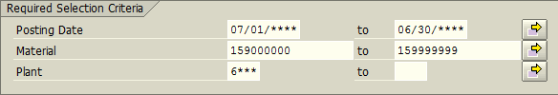
- Click the Multiple Selection icon (Right-side of the right column)
A new window appears
Input the following as exhibited.
When lower and upper limits keyed, click the execute icon in the bottom left corner.
- This will return the software to the main ZMB20 screen.
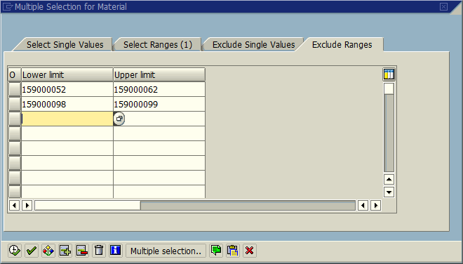

- Input the following as exhibited:
- One Exception – Material Document Number will auto-populate.
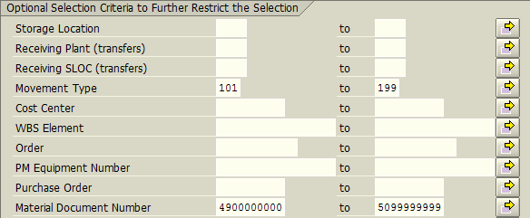
- Click the Execute icon (Upper left corner of the screen)
A new window appears – Scroll to the right; click on the column header; Total Transaction Value
- The above action selects the entire column.
Click the Total icon - This will total the contents; scroll down to see the total and record the value within the Excel spreadsheet.
- The example below is only for one month; it is merely a demonstration.
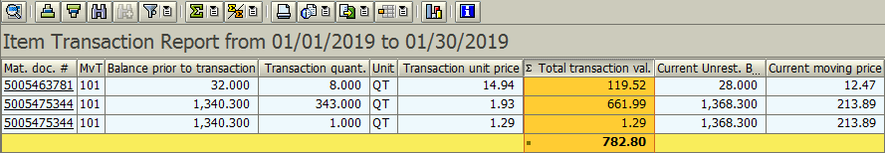

- Click the Exit icon once to begin the process for Line C.

- Inventory Used - Open Transaction: ZMB20
- Line C mimics Line B with one exception Movement Types change from (101 & 199) to (261 & 262). If you have not exited ZMB20, you may go to Step c.

- Input the following as exhibited:
- Exception #1 – Change postings dates to: 07/01/2019; 06/30/2020
- Exception #2 – Change plant to your LEAs plant code.
- Click the Multiple Selection icon (Right-side of the right column)
A new window appears
Input the following as exhibited. When lower and upper limits keyed, click the execute icon in the bottom left corner.
- This will return the software to the main ZMB20 screen.
- Input the following as exhibited:
- One Exception – Material Document Number will auto-populate.
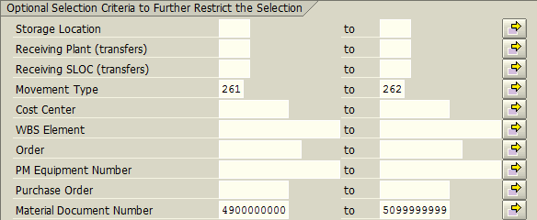
- Click the Execute icon (Upper left corner of the screen)
A new window appears – Scroll to the right; click on the column header; Total Transaction Value
- The above action selects the entire column.
Click the Total icon - This will total the contents; scroll down to see the total and record the value within the Excel spreadsheet.
- The example below is only for one-month; it is merely a demonstration.
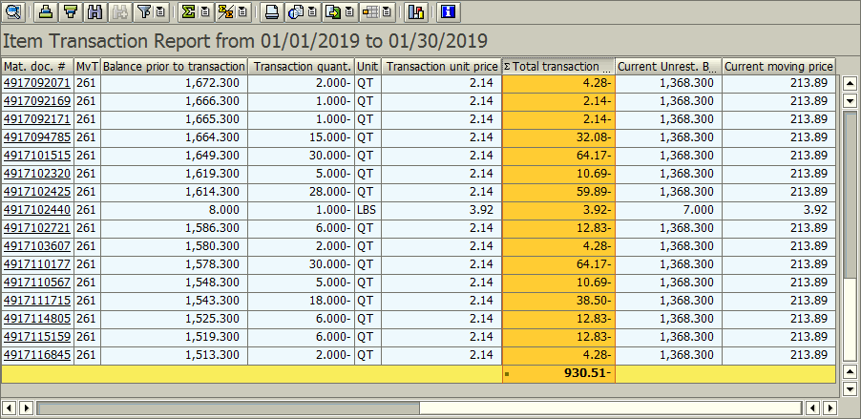

- Click the Exit icon twice to begin the process for Line D.
- Ending Inventory (Actual) - Open Transaction: ZMB19
- You must pull line D data on the last working day of June 2020 in the evening, or the first working day of July 2020 first thing in the morning.

- Input the following as exhibited:
- One Exception – Change plant to your LEAs plant code.
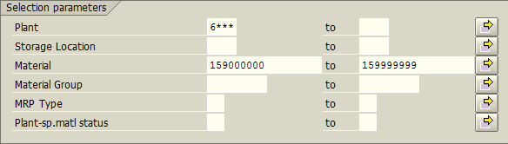
- Click the Multiple Selection icon (Right-side of the right column)
A new window appears
Input the following as exhibited. When lower and upper limits keyed, click the execute icon in the bottom left corner.
- This will return the software to the main ZMB19 screen.
- Input the following as exhibited:
- Change the Period of Total usage to 12/2020 for both fields. Otherwise, the software will run slower. 2019
- Click the Execute icon (Upper left corner of the screen)
A new window appears – Scroll to the right; click on the column header; Total Value
- The above action selects the entire column.
Click the Total icon - This will total the contents; scroll down to see the total and record the value within the Excel spreadsheet.
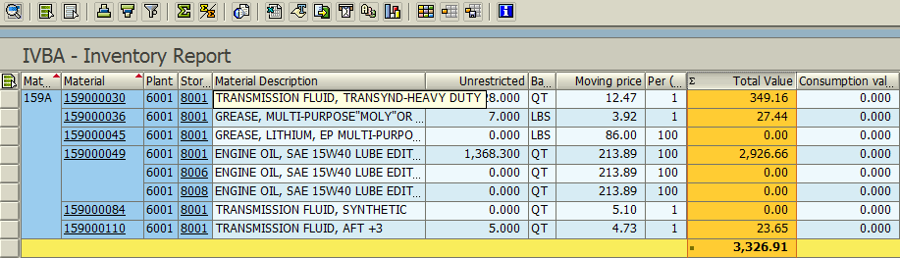

- Click the Exit icon twice to begin the process for Line E.

- Inventory Adjustments (Additions) - Open Transaction: ZMB20
- Line E mimics Line C with one exception Movement Types change from (261 & 262) to (701). If you have not exited ZMB20, you may go to Step c.

- Input the following as exhibited:
- Exception #1 – Change postings dates to: 07/01/2019; 06/30/2020
- Exception #2 – Change plant to your LEAs plant code.
- Click the Multiple Selection icon (Right-side of the right column)
A new window appears
Input the following as exhibited.
When lower and upper limits keyed, click the execute icon in the bottom left corner.
- This will return the software to the main ZMB20 screen.
- Input the following as exhibited:
- One Exception – Material Document Number will auto-populate.
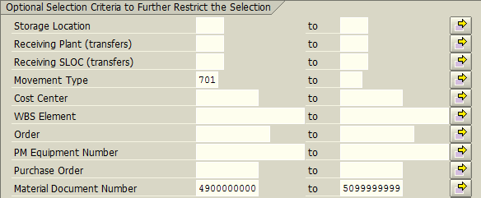
- Click the Execute icon (Upper left corner of the screen)
- If no adjustment – the message “No data was found for selection criteria entered” appears. Enter zero for line E; otherwise continue with the steps.
A new window appears – Scroll to the right; click on the column header; Total Transaction Value
- The above action selects the entire column.
Click the Total icon - This will total the contents; scroll down to see the total and record the value within the Excel spreadsheet.
- The example below is only for a one-month; it is merely a demonstration.

- Click the Exit icon once to begin the process for Line F.
- Inventory Adjustments (Deletions) - Open Transaction: ZMB20
- Line F mimics Line E with one exception Movement Types changes from 701 to 702. If you have not exited ZMB20, you may go to Step c.

- Input the following as exhibited:
- Exception #1 – Change postings dates to: 07/01/2019; 06/30/2020
- Exception #2 – Change plant to your LEAs plant code.
- Click the Multiple Selection icon (Right-side of the right column)
A new window appears
Input the following as exhibited. When lower and upper limits keyed, click the execute icon in the bottom left corner.
- This will return the software to the main ZMB20 screen.
- Input the following as exhibited:
- One Exception – Material Document Number will auto-populate.
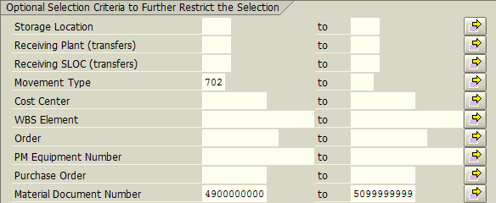
- Click the Execute icon (Upper left corner of the screen)
- If no adjustment – the message “No data was found for selection criteria entered” appears. Enter zero for line F; otherwise continue with the steps.
A new window appears – Scroll to the right; click on the column header; Total Transaction Value
- The above action selects the entire column.
Click the Total icon - This will total the contents; scroll down to see the total and record the value within the Excel spreadsheet.
- The example below is only for one-month; it is merely a demonstration.

- Click the Exit icon once to begin the process for Line G.
- Inventory Transferred to/from another LEA - Open Transaction: ZMB20
- Line G mimics Line F with one exception Movement Types change from 702 to (303 & 304). If you have not exited ZMB20, you may go to Step c.

- Input the following as exhibited:
- Exception #1 – Change postings dates to: 07/01/2019; 06/30/2020
- Exception #2 – Change plant to your LEAs plant code.
- Click the Multiple Selection icon (Right-side of the right column)
A new window appears
Input the following as exhibited.
When lower and upper limits keyed, click the execute icon in the bottom left corner.
- This will return the software to the main ZMB20 screen.
- Input the following as exhibited:
- One Exception – Material Document Number will auto-populate.
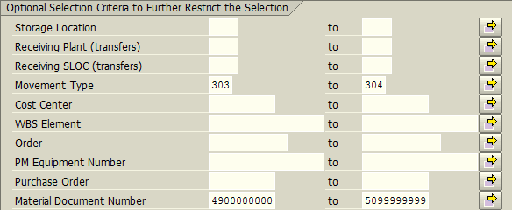
- Click the Execute icon (Upper left corner of the screen)
- If no transfers – the message “No data was found for selection criteria entered” appears. Enter zero for line G; otherwise continue with the steps.
A new window appears – Scroll to the right; click on the column header; Total Transaction Value
- The above action selects the entire column.
Click the Total icon - This will total the contents; scroll down to see the total and record the value within the Excel spreadsheet.
- The example below is only for one month; it is merely a demonstration.

- Click the Exit icon twice to return to the main menu.
- Removed Obsolete/Damaged Inventory
- Line H will flow automatically from the detailed accounting on the Obsolete Inventory Worksheet.

Tire Quantity (New & Recaps) – (Charge Account code: 425)

- This information on the breakdown of tire DOT numbers is LEA specific; values are determined via a different procedure.

- It is required you complete this procedure twice; the first time for new tires and the second time for recap tires.

Quick Computation Reference
 |  |  | Date |  | Material
Ln | Trans./Form | Col. | Range | Plant | Include | Exclude | Type | Total
A | TD-1 | -- | Prior Yr. | -- | -- | -- | -- | Line D
B | ZMB20 | Left | 07/01/2019 | 6### | See note | -- | 101 | Total Trans. Quantity
 |  | Right | 06/30/2020 |  | below |  | 199
C | ZMB20 | Left | 07/01/2019 | 6### | See note | -- | 261 | Total Trans. Quantity
 |  | Right | 06/30/2020 |  | below |  | 262
D | ZMB19 | Left | 12/2020 | 6### | See note | -- | -- | Total Quantity
 |  | Right | 12/2020 |  | below
E | ZMB20 | Left | 07/01/2019 | 6### | See note | -- | 701 | Total Trans. Quantity
 |  | Right | 06/30/2020 |  | below
F | ZMB20 | Left | 07/01/2019 | 6### | See note | -- | 702 | Total Trans. Quantity
 |  | Right | 06/30/2020 |  | below
G | ZMB20 | Left | 07/01/2019 | 6### | See note | -- | 303 | Total Trans. Quantity
 |  | Right | 06/30/2020 |  | below |  | 304
H | ZMB20 | Left | 07/01/2019 | 6### | See note | -- | 201 | Total Trans. Quantity
 |  | Right | 06/30/2020 |  | below |  | 202

Note: Dependent upon cycle (New vs Recap); enter the new or recap DOT tire numbers that apply to your specific LEA.
- Beginning Inventory
Two options to retrieve this information
- Option 1 – Prior year’s ZMB19 spreadsheet used to complete TD-1; or
- Option 2 – Prior year’s TD-1 Line D – Ending Actual Inventory
- Inventory Purchased - Open Transaction: ZMB20
- Input the following as exhibited:
- Exception #1 – Change postings dates to: 07/01/2019; 06/30/2020
- Exception #2 – Dependent upon cycle (New vs Recap); enter the first new or recap DOT tire number that applies to your specific LEA.
- Exception #3 - Change plant to your LEAs plant code.
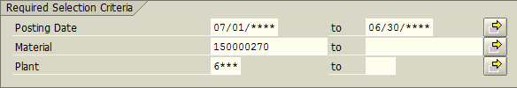
- Click the Multiple Selection icon (Right-side of the right column)
A new window appears
Input the following as exhibited.
- Exception – Dependent upon cycle (New vs Recap); enter the remaining new or recap DOT tire numbers that apply to your specific LEA.
When all are keyed, click the execute icon in the bottom left corner.
- This will return the software to the main ZMB20 screen.
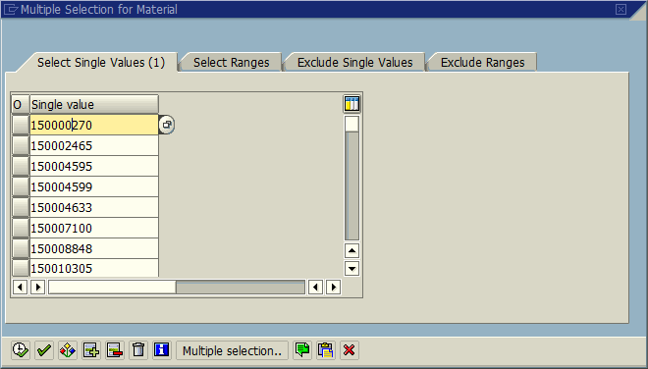
- Input the following as exhibited:
- One Exception – Material Document Number will auto-populate.
- Click the Execute icon (Upper left corner of the screen)
A new window appears – Scroll to the right; click on the column header; Transaction Quantity
- The above action selects the entire column.
Click the Total icon - This will total the contents; scroll down to see the total and record the value within the Excel spreadsheet.
- The example below is only for a few-months span; it is merely a demonstration.
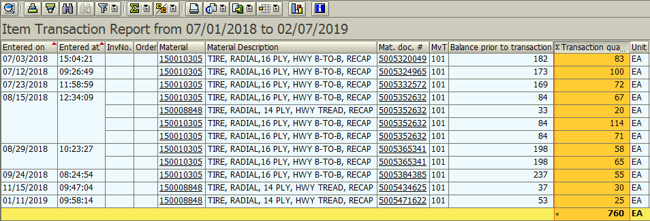

- Click the Exit icon once to begin the process for Line C.

- Inventory Used - Open Transaction: ZMB20
- Line C mimics Line B with one exception Movement Types change from (101 & 199) to (261 & 262). If you have not exited ZMB20, you may go to Step c.

- Input the following as exhibited:
- Exception #1 – Change postings dates to: 07/01/2019; 06/30/2020
- Exception #2 – Dependent upon cycle (New vs Recap); enter the first new or recap DOT tire number that applies to your specific LEA.
- Exception #3 - Change plant to your LEAs plant code.
- Click the Multiple Selection icon (Right-side of the right column)
A new window appears
- Exception – Dependent upon cycle (New vs Recap); enter the remaining new or recap DOT tire numbers that apply to your specific LEA.
When all are keyed, click the execute icon in the bottom left corner.
- This will return the software to the main ZMB20 screen.

- Input the following as exhibited:
- One Exception – Material Document Number will auto-populate.
- Click the Execute icon (Upper left corner of the screen)
A new window appears – Scroll to the right; click on the column header; Transaction Quantity
- The above action selects the entire column.
Click the Total icon - This will total the contents; scroll down to see the total and record the value within the Excel spreadsheet.
- The example below is only for one-month; it is merely a demonstration.
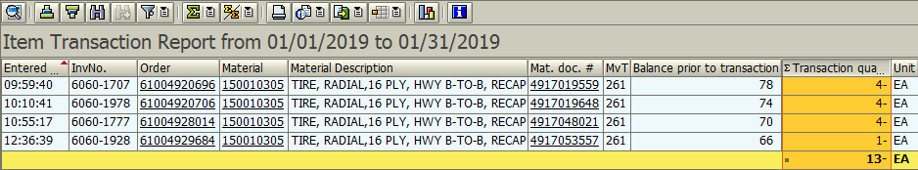

- Click the Exit icon twice to begin the process for Line D.
- Ending Inventory (Actual) - Open Transaction: ZMB19
- You must pull line D data on the last working day of June 2020 in the evening, or the first working day of July 2020 first thing in the morning.

- Input the following as exhibited:
- One Exception – Change plant to your LEAs plant code.
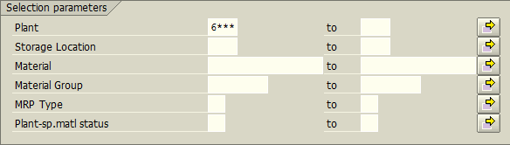
- Click the Multiple Selection icon (Right-side of the right column)
A new window appears
Input the following as exhibited.
- Exception – Dependent upon cycle (New vs Recap); enter the new or recap DOT tire numbers that apply to your specific LEA.
When all are keyed, click the execute icon in the bottom left corner.
- This will return the software to the main ZMB19 screen.

- Input the following as exhibited:
- Change the Period of Total usage to 12-2020 for both fields. Otherwise, the software will run slower.
- Click the Execute icon (Upper left corner of the screen)
A new window appears – Scroll to the right; click on the column header; Unrestricted
- The above action selects the entire column.
Click the Total icon - This will total the contents; scroll down to see the total and record the value within the Excel spreadsheet.
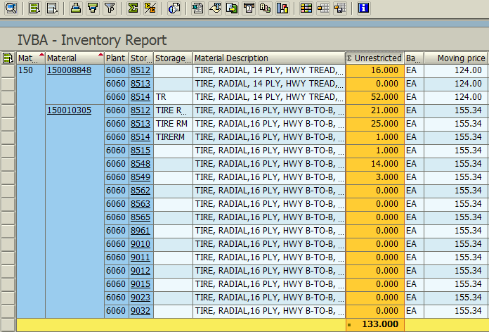

- Click the Exit icon twice to begin the process for Line E.
- Inventory Adjustments (Additions) - Open Transaction: ZMB20
- Line E mimics Line C with one exception Movement Types change from (261 & 262) to (701). If you have not exited ZMB20, you may go to Step c.

- Input the following as exhibited:
- Exception #1 – Change postings dates to: 07/01/2019; 06/30/2020
- Exception #2 – Dependent upon cycle (New vs Recap); enter the first new or recap DOT tire number that applies to your specific LEA.
- Exception #3 - Change plant to your LEAs plant code.
- Click the Multiple Selection icon (Right-side of the right column)
A new window appears
- Exception – Dependent upon cycle (New vs Recap); enter the remaining new or recap DOT tire numbers that apply to your specific LEA.
- This will return the software to the main ZMB20 screen.
- Input the following as exhibited:
- One Exception – Material Document Number will auto-populate.
- Click the Execute icon (Upper left corner of the screen)
- If no adjustment – the message “No data was found for selection criteria entered” appears. Enter zero for line E; otherwise continue with the steps.
A new window appears – Scroll to the right; click on the column header; Transaction Quantity
- The above action selects the entire column.
Click the Total icon - This will total the contents; scroll down to see the total and record the value within the Excel spreadsheet.
- The example below is only for a short span; it is merely a demonstration.
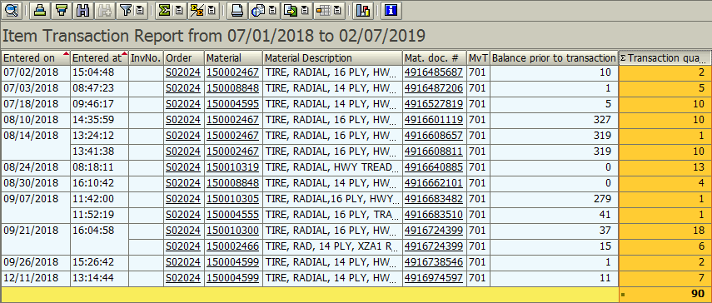

- Click the Exit icon once to begin the process for Line F.
- Inventory Adjustments (Deletions) - Open Transaction: ZMB20
- Line F mimics Line E with one exception Movement Types changes from 701 to 702. If you have not exited ZMB20, you may go to Step c.

- Input the following as exhibited:
- Exception #1 – Change postings dates to: 07/01/2019; 06/30/2020
- Exception #2 – Dependent upon cycle (New vs Recap); enter the first new or recap DOT tire number that applies to your specific LEA.
- Exception #3 - Change plant to your LEAs plant code.
- Click the Multiple Selection icon (Right-side of the right column)
A new window appears
Input the following as exhibited
- Exception – Dependent upon cycle (New vs Recap); enter the remaining new or recap DOT tire numbers that apply to your specific LEA.
- This will return the software to the main ZMB20 screen.

- Input the following as exhibited:
- One Exception - Material Document Number will auto-populate.
- Click the Execute icon (Upper left corner of the screen)
- If no adjustment – the message “No data was found for selection criteria entered” appears. Enter zero for line F; otherwise continue with the steps.
A new window appears – Scroll to the right; click on the column header; Transaction Quantity
- The above action selects the entire column.
Click the Total icon - This will total the contents; scroll down to see the total and record the value within the Excel spreadsheet.
- The example below is only for a short span; it is merely a demonstration.
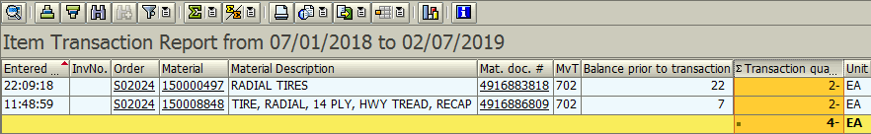

- Click the Exit icon once to begin the process for Line G.
- Inventory Transferred to/from another LEA - Open Transaction: ZMB20
- Line G mimics Line F with one exception Movement Types change from 702 to (303 & 304). If you have not exited ZMB20, you may go to Step c.

- Input the following as exhibited:
- Exception #1 – Change postings dates to: 07/01/2019; 06/30/2020
- Exception #2 – Dependent upon cycle (New vs Recap); enter the first new or recap DOT tire number that applies to your specific LEA.
- Exception #3 - Change plant to your LEAs plant code.
- Click the Multiple Selection icon (Right-side of the right column)
A new window appears
Input the following as exhibited.
- Exception – Dependent upon cycle (New vs Recap); enter the remaining new or recap DOT tire numbers that apply to your specific LEA.
- This will return the software to the main ZMB20 screen.

- Input the following as exhibited:
- One Exception – Material Document Number will auto-populate.
- Click the Execute icon (Upper left corner of the screen)
- If no transfers – the message “No data was found for selection criteria entered” appears. Enter zero for line G; otherwise continue with the steps.
A new window appears – Scroll to the right; click on the column header; Transaction Quantity
- The above action selects the entire column.
Click the Total icon - This will total the contents; scroll down to see the total and record the value within the Excel spreadsheet.
- The example below is only for a short span; it is merely a demonstration.
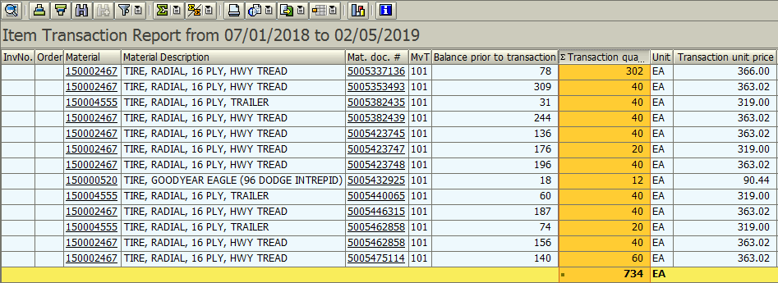

- Click the Exit icon once to begin the process for Line H.
- Removed Obsolete/Damaged Inventory - Open Transaction: ZMB20
- Line H mimics Line G with one exception Movement Types change from (303 & 304) to (201 to 202). If you have not exited ZMB20, you may go to Step c.

- Input the following as exhibited:
- Exception #1 – Change postings dates to: 07/01/2019; 06/30/2020
- Exception #2 – Dependent upon cycle (New vs Recap); enter the first new or recap DOT tire number that applies to your specific LEA.
- Exception #3 - Change plant to your LEAs plant code.
- Click the Multiple Selection icon (Right-side of the right column)
A new window appears
Input the following as exhibited.
- Exception – Dependent upon cycle (New vs Recap); enter the remaining new or recap DOT tire numbers that apply to your specific LEA.
- This will return the software to the main ZMB20 screen.

- Input the following as exhibited:
- One Exception – Material Document Number will auto-populate.
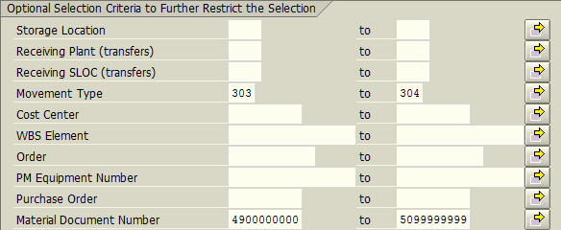
- Click the Execute icon (Upper left corner of the screen)
- If no obsolete inventory – the message “No data was found for selection criteria entered” appears. Enter zero for line H; otherwise continue with the steps.
A new window appears – Scroll to the right; click on the column header; Transaction Quantity
- The above action selects the entire column.
Click the Total icon - This will total the contents; scroll down to see the total and record the value within the Excel spreadsheet.
- The example below is only for a short span; it is merely a demonstration.
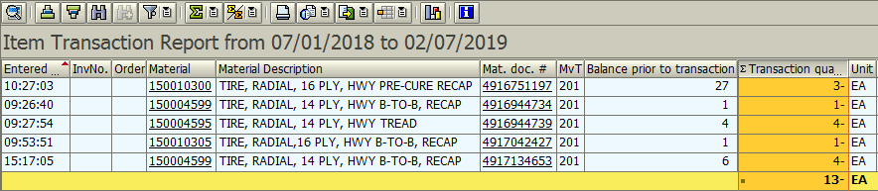

- Click the Exit icon twice to return to the main menu.
Tire Value (All) – (Charge Account code: 425)

- This procedure may capture items such as tubes and stems. However, please follow the instructions as defined.

Quick Computation Reference

 |  |  | Date |  | Material
Ln | Trans./Form | Col. | Range | Plant | Include | Exclude | Type | Total
A | TD-1 | -- | Prior Yr. | -- | -- | -- | -- | Line D
B | ZMB20 | Left | 07/01/2019 | 6### | 150000000 | -- | 101 | Total Trans. Value
 |  | Right | 06/30/2020 |  | 150999999 |  | 199
C | ZMB20 | Left | 07/01/2019 | 6### | 150000000 | -- | 261 | Total Trans. Value
 |  | Right | 06/30/2020 |  | 150999999 |  | 262
D | ZMB19 | Left | 12/2020 | 6### | 150000000 | -- | -- | Total Value
 |  | Right | 12/2020 |  | 150999999
E | ZMB20 | Left | 07/01/2019 | 6### | 150000000 | -- | 701 | Total Trans. Value
 |  | Right | 06/30/2020 |  | 150999999
F | ZMB20 | Left | 07/01/2019 | 6### | 150000000 | -- | 702 | Total Trans. Value
 |  | Right | 06/30/2020 |  | 150999999
G | ZMB20 | Left | 07/01/2019 | 6### | 150000000 | -- | 303 | Total Trans. Value
 |  | Right | 06/30/2020 |  | 150999999 |  | 304
H | Obsolete Inv | -- | -- | -- | -- | -- | -- | Automatic
 | Worksheet

- Beginning Inventory
Two options to retrieve this information
- Option 1 – Prior year’s ZMB19 spreadsheet used to complete TD-1; or
- Option 2 – Prior year’s TD-1 Line D – Ending Actual Inventory

- Inventory Purchased - Open Transaction: ZMB20
- Input the following as exhibited:
- Exception #1 – Change postings dates to: 07/01/2019; 06/30/2020
- Exception #2 - Change plant to your LEAs plant code.
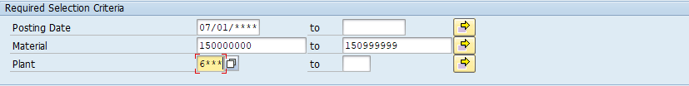
- Input the following as exhibited:
- One Exception – Material Document Number will auto-populate.
- Click the Execute icon (Upper left corner of the screen)
A new window appears – Scroll to the right; click on the column header; Total Transaction Value
- The above action selects the entire column.
Click the Total icon - This will total the contents; scroll down to see the total and record the value within the Excel spreadsheet.
- The example below is only for a few-months span; it is merely a demonstration.
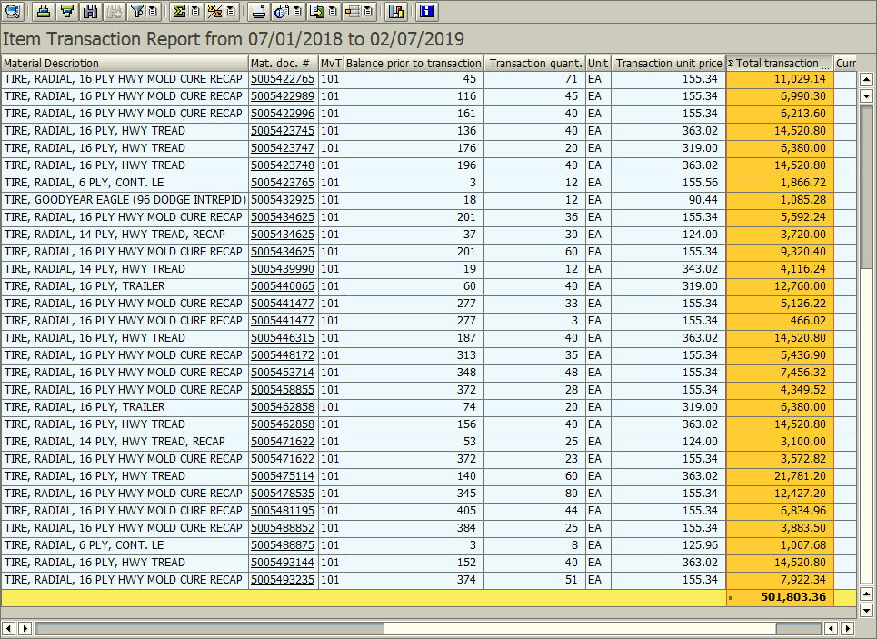

- Click the Exit icon once to begin the process for Line C.

- Inventory Used - Open Transaction: ZMB20
- Line C mimics Line B with one exception Movement Types change from (101 & 199) to (261 & 262). If you have not exited ZMB20, you may go to Step b.

- Input the following as exhibited:
- Exception #1 – Change postings dates to: 07/01/2019; 06/30/2020
- Exception #2 - Change plant to your LEAs plant code.
- Input the following as exhibited:
- One Exception – Material Document Number will auto-populate.
- Click the Execute icon (Upper left corner of the screen)
A new window appears – Scroll to the right; click on the column header; Total Transaction Value
- The above action selects the entire column.
Click the Total icon - This will total the contents; scroll down to see the total and record the value within the Excel spreadsheet.
- The example below is only for one month; it is merely a demonstration.
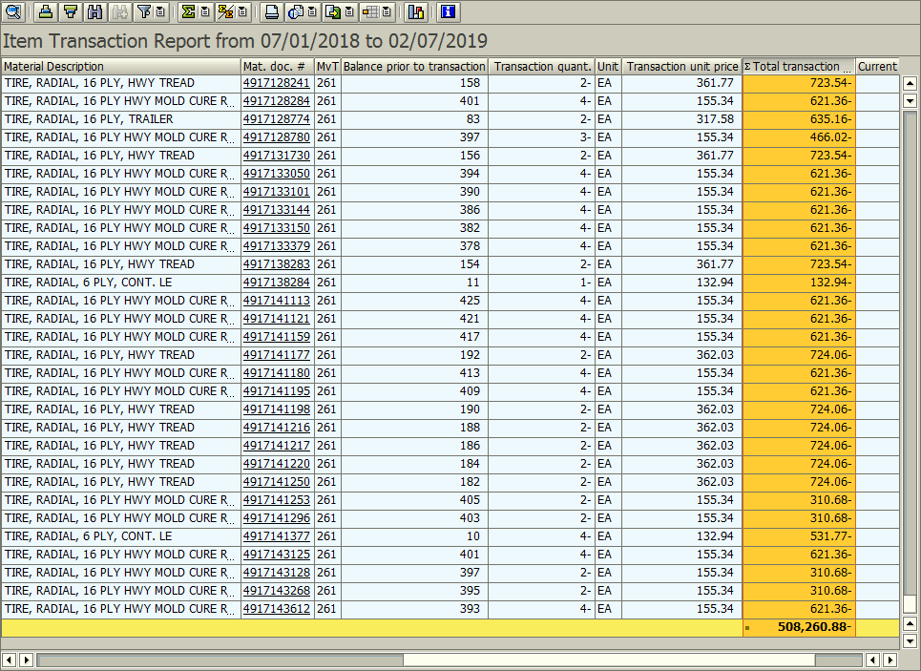

- Click the Exit icon twice to begin the process for Line D.
- Ending Inventory (Actual) - Open Transaction: ZMB19
- You must pull line D data on the last working day of June 2020 in the evening, or the first working day of July 2020 first thing in the morning.

- Input the following as exhibited:
- One Exception – Change plant to your LEAs plant code.
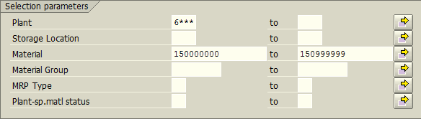
- Input the following as exhibited:
- Change the Period of Total usage to 12-2020 for both fields. Otherwise, the software will run slower.
- Click the Execute icon (Upper left corner of the screen)
A new window appears – Scroll to the right; click on the column header; Total Value
- The above action selects the entire column.
Click the Total icon - This will total the contents; scroll down to see the total and record the value within the Excel spreadsheet.
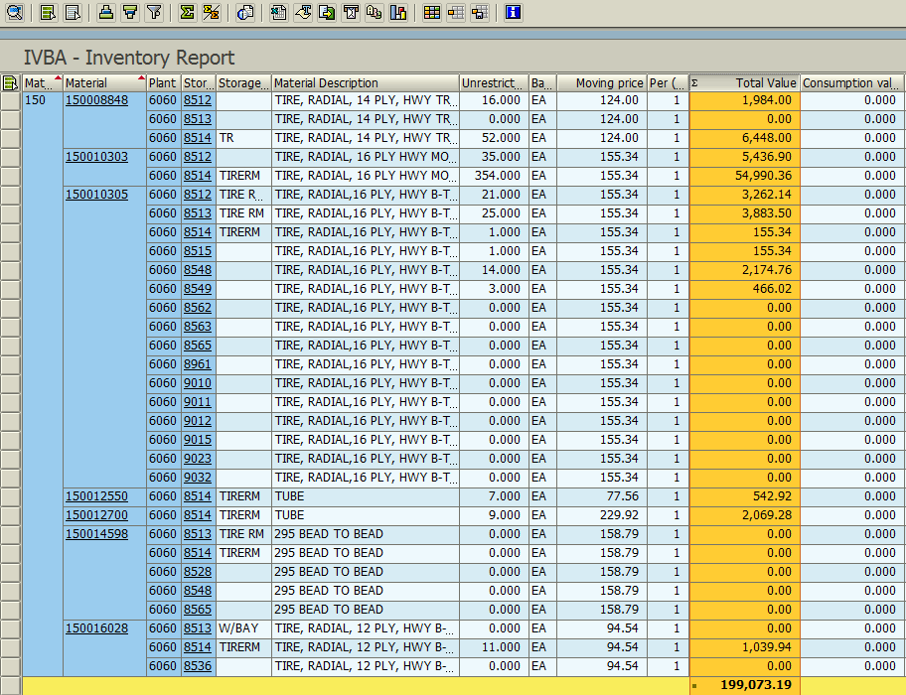

- Click the Exit icon twice to begin the process for Line E.

- Inventory Adjustments (Additions) - Open Transaction: ZMB20
- Line E mimics Line C with one exception Movement Types change from (261 & 262) to (701). If you have not exited ZMB20, you may go to Step c.

- Input the following as exhibited:
- Exception #1 – Change postings dates to: 07/01/2019; 06/30/2020
- Exception #2 - Change plant to your LEAs plant code.
- Input the following as exhibited:
- One Exception – Material Document Number will auto-populate.

- Click the Execute icon (Upper left corner of the screen)
- If no adjustment – the message “No data was found for selection criteria entered” appears. Enter zero for line E; otherwise continue with the steps.
A new window appears – Scroll to the right; click on the column header; Total Transaction Value
- The above action selects the entire column.
Click the Total icon - This will total the contents; scroll down to see the total and record the value within the Excel spreadsheet.
- The example below is only for a short span; it is merely a demonstration.
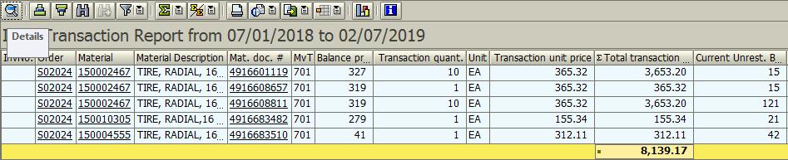

- Click the Exit icon once to begin the process for Line F.
- Inventory Adjustments (Deletions) - Open Transaction: ZMB20
- Line F mimics Line E with one exception Movement Types change from 701 to 702. If you have not exited ZMB20 you may go to Step b.

- Input the following as exhibited:
- Exception #1 – Change postings dates to: 07/01/2019; 06/30/2020
- Exception #2 - Change plant to your LEAs plant code.
- Input the following as exhibited:
- One Exception - Material Document Number will auto populate.

- Click the Execute icon (Upper left corner of the screen)
- If no adjustment – the message “No data was found for selection criteria entered” appears. Enter zero for line F; otherwise continue with the steps.
A new window appears – Scroll to the right; click on the column header; Total Transaction Value
- The above action selects the entire column.
Click the Total icon - This will total the contents; scroll down to see the total and record the value within the Excel spreadsheet.
- The example below is only for a short span; it is merely a demonstration.
- Also, the example below is for Movement Type 701; at the time of this writing Movement Type 702 was not used in the LEA used for the examples.

- Click the Exit icon once to begin the process for Line G.
- Inventory Transferred to/from another LEA - Open Transaction: ZMB20
- Line G mimics Line F with one exception Movement Types change from 702 to (303 & 304). If you have not exited ZMB20 you may go to Step b.

- Input the following as exhibited:
- Exception #1 – Change postings dates to: 07/01/2019; 06/30/2020
- Exception #2 - Change plant to your LEAs plant code.
- Input the following as exhibited:
- One Exception – Material Document Number will auto populate.
- Click the Execute icon (Upper left corner of the screen)
- If no transfers – the message “No data was found for selection criteria entered” appears. Enter zero for line G; otherwise continue with the steps.
A new window appears – Scroll to the right; click on the column header; Total Transaction Value
- The above action selects the entire column.
Click the Total icon - This will total the contents; scroll down to see the total and record the value within the Excel spreadsheet.
- The example below is only for a short span; it is merely a demonstration.
- Also, the example below is for Movement Type 701; at the time of this writing Movement Types 303 or 304 were not used in the LEA used for the examples.

- Click the Exit icon twice to return to the main menu.

- Removed Obsolete/Damaged Inventory
- Line H will flow automatically from the detailed accounting on the Obsolete Inventory Worksheet

Repair Parts Value – (Charge Account code: 422)

Quick Computation Reference

 |  |  | Date |  | Material
Ln | Trans./Form | Col. | Range | Plant | Include | Exclude | Type | Total
A | TD-1 | -- | Prior Yr. | -- | -- | -- | -- | Line D
B | ZMB20 | Left | 07/01/2019 | 6### | 155000000 | 181099035 | 101 | Total Trans. Value
 |  | Right | 06/30/2020 |  | 155999999 |  | 199
 |  | Left |  |  | 180000000
 |  | Right |  |  | ZZZ99999
C | ZMB20 | Left | 07/01/2019 | 6### | 155000000 | 181099035 | 261 | Total Trans. Value
 |  | Right | 06/30/2020 |  | 155999999 |  | 262
 |  | Left |  |  | 180000000
 |  | Right |  |  | ZZZ99999
D | ZMB19 | Left | 12/2020 | 6### | 155000000 | 181099035 | -- | Total Value
 |  | Right | 12/2020 |  | 155999999
 |  | Left |  |  | 180000000
 |  | Right |  |  | ZZZ99999
E | ZMB20 | Left | 07/01/2019 | 6### | 155000000 | 181099035 | 701 | Total Trans. Value
 |  | Right | 06/30/2020 |  | 155999999
 |  | Left |  |  | 180000000
 |  | Right |  |  | ZZZ99999
F | ZMB20 | Left | 07/01/2019 | 6### | 155000000 | 181099035 | 702 | Total Trans. Value
 |  | Right | 06/30/2020 |  | 155999999
 |  | Left |  |  | 180000000
 |  | Right |  |  | ZZZ99999
G | ZMB20 | Left | 07/01/2019 | 6### | 155000000 | 181099035 | 303 | Total Trans. Value
 |  | Right | 06/30/2020 |  | 155999999 |  | 304
 |  | Left |  |  | 180000000
 |  | Right |  |  | ZZZ99999
H | Obsolete Inv | -- | -- | -- | -- | -- | -- | Automatic
 | Worksheet

- Beginning Inventory
Two options to retrieve this information
- Option 1 – Prior year’s ZMB19 spreadsheet used to complete TD-1; or
- Option 2 – Prior year’s TD-1 Line D – Ending Actual Inventory

- Inventory Purchased - Open Transaction: ZMB20
- Input the following as exhibited:
- Exception #1 – Change postings dates to: 07/01/2019; 06/30/2020
- Exception #2 - Change plant to your LEAs plant code.
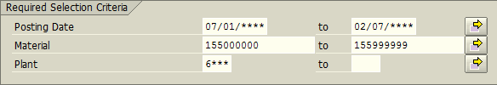
- Click the Multiple Selection icon (Right-side of the right column)
A new window appears
Input the following as exhibited
When lower and upper limits keyed; click the “Exclude Single Values” Tab.
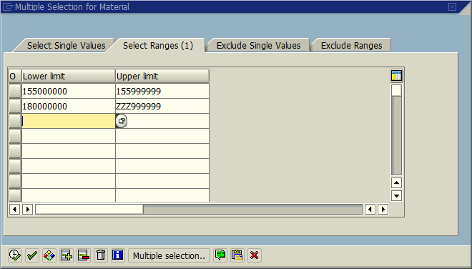
- Input the following as exhibited
When the Exclude Single Value is keyed; click the execute icon in bottom left corner.
- This will return the software to the main ZMB20 screen.
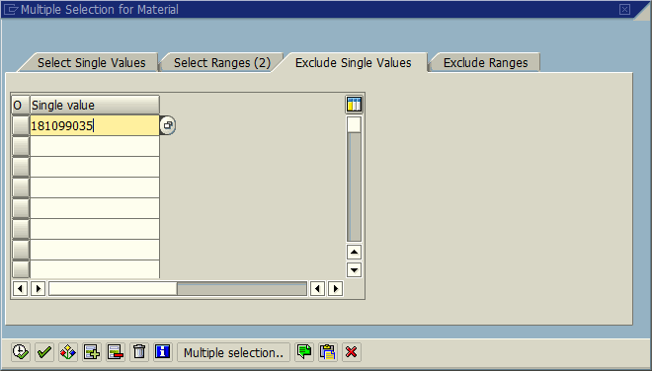
- Input the following as exhibited:
- One Exception – Material Document Number will auto-populate.
- Click the Execute icon (Upper left corner of the screen)
A new window appears – Scroll to the right; click on the column header; Total Transaction Value
- The above action selects the entire column.
Click the Total icon - This will total the contents; scroll down to see the total and record the value within the Excel spreadsheet.
- The example below is only for a few-months span; it is merely a demonstration.
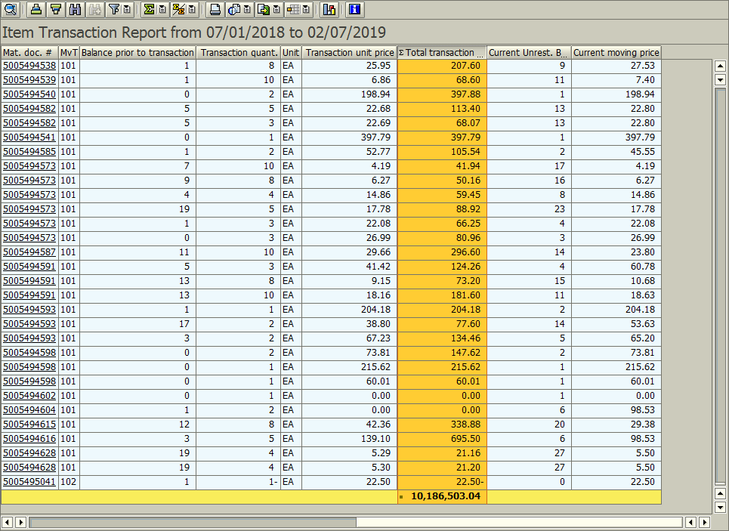

- Click the Exit icon once to begin the process for Line C.

- Inventory Used - Open Transaction: ZMB20
- Line C mimics Line B with one exception Movement Types change from (101 & 199) to (261 & 262). If you have not exited ZMB20 you may go to Step b.

- Input the following as exhibited:
- Exception #1 – Change postings dates to: 07/01/2019; 06/30/2020
- Exception #2 - Change plant to your LEAs plant code.
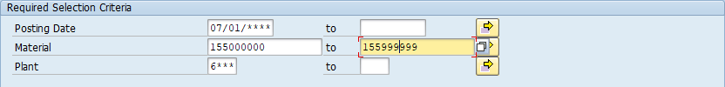

- Click the Multiple Selection icon (Right-side of the right column)
A new window appears
Input the following as exhibited
When lower and upper limits keyed; click the “Exclude Single Values” Tab.
- Input the following as exhibited
When the Exclude Single Value is keyed; click the execute icon in bottom left corner.
- This will return the software to the main ZMB20 screen.
- Input the following as exhibited:
- One Exception – Material Document Number will auto populate.
- Click the Execute icon (Upper left corner of the screen)
A new window appears – Scroll to the right; click on the column header; Total Transaction Value
- The above action selects the entire column.
Click the Total icon - This will total the contents; scroll down to see the total and record the value within the Excel spreadsheet.
- The example below is only for a short span; it is merely a demonstration.
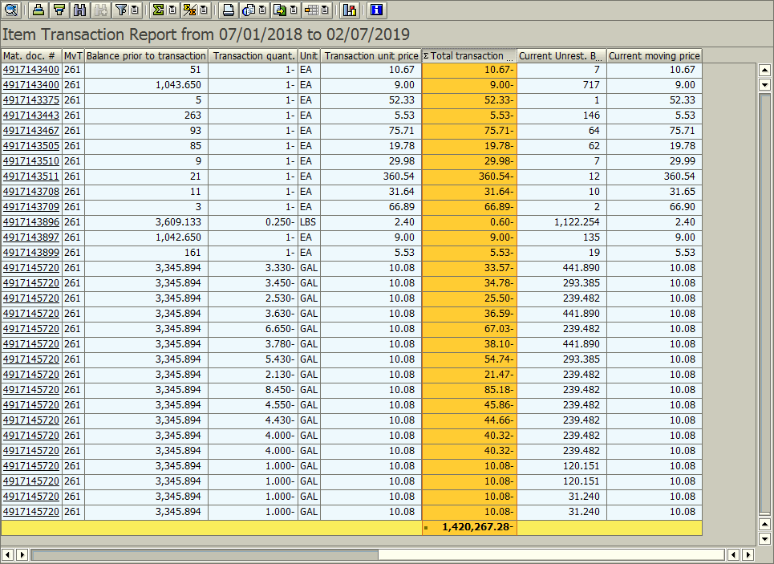

- Click the Exit icon twice to begin the process for Line D.
- Ending Inventory (Actual) - Open Transaction: ZMB19
- You must pull line D data on the last working day of June 2020 in the evening, or the first working day of July 2020 first thing in the morning.

- Input the following as exhibited:
- One Exception – Change plant to your LEAs plant code.
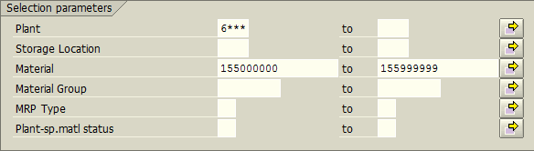

- Click the Multiple Selection icon (Right-side of the right column)
A new window appears
Input the following as exhibited
When lower and upper limits keyed; click the “Exclude Single Values” Tab.
- Input the following as exhibited
When the Exclude Single Value is keyed; click the execute icon in bottom left corner.
- This will return the software to the main ZMB19 screen.

- Input the following as exhibited:
- Change the Period of Total usage to 12-2020 for both fields. Otherwise software will run slower.
- Click the Execute icon (Upper left corner of the screen)
A new window appears – Scroll to the right; click on the column header; Total Value
- The above action selects the entire column.
Click the Total icon - This will total the contents; scroll down to see the total and record the value within the Excel spreadsheet.
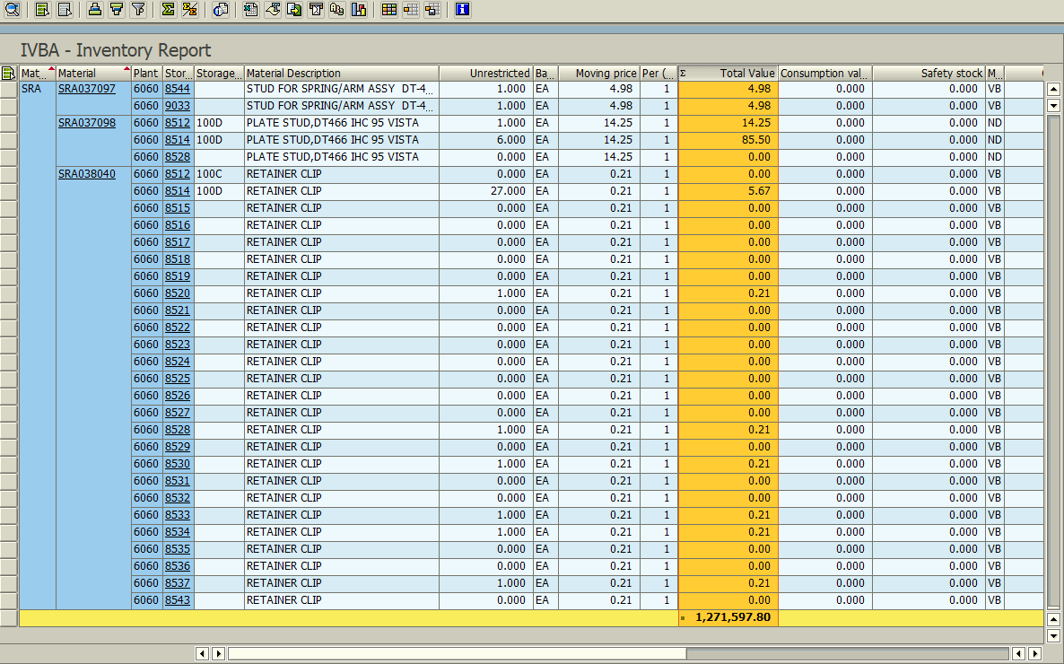

- Click the Exit icon twice to begin the process for Line E.

- Inventory Adjustments (Additions) - Open Transaction: ZMB20
- Line E mimics Line C with one exception Movement Types change from (261 & 262) to (701). If you have not exited ZMB20 you may go to Step c.

- Input the following as exhibited:
- Exception #1 – Change postings dates to: 07/01/2019; 06/30/2020
- Exception #2 - Change plant to your LEAs plant code.
- Click the Multiple Selection icon (Right-side of the right column)
A new window appears
Input the following as exhibited
When lower and upper limits keyed; click the “Exclude Single Values” Tab.
- Input the following as exhibited
When the Exclude Single Value is keyed; click the execute icon in bottom left corner.
- This will return the software to the main ZMB20 screen.
- Input the following as exhibited:
- One Exception – Material Document Number will auto populate.

- Click the Execute icon (Upper left corner of the screen)
- If no adjustment – the message “No data was found for selection criteria entered” appears. Enter zero for line E; otherwise continue with the steps.
A new window appears – Scroll to the right; click on the column header; Total Transaction Value
- The above action selects the entire column.
Click the Total icon - This will total the contents; scroll down to see the total and record the value within the Excel spreadsheet.
- The example below is only for a short span; it is merely a demonstration.
- 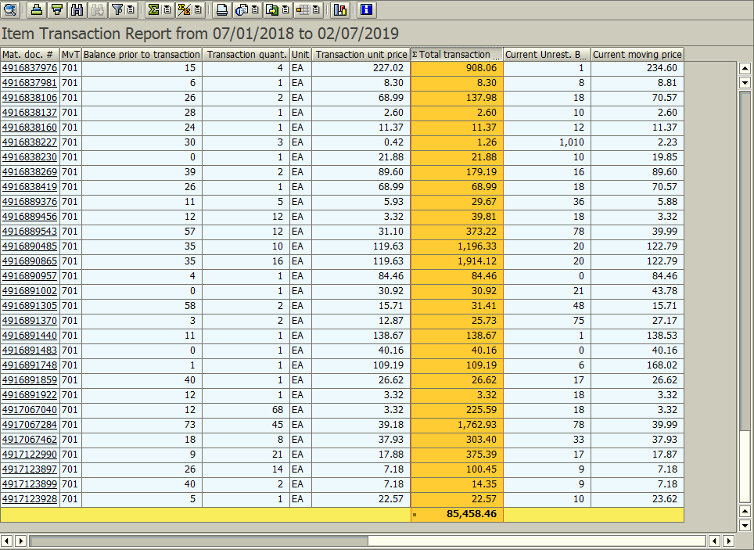

- Click the Exit icon once to begin the process for Line F.
- Inventory Adjustments (Deletions) - Open Transaction: ZMB20
- Line F mimics Line E with one exception Movement Types change from 701 to 702. If you have not exited ZMB20 you may go to Step c.

- Input the following as exhibited:
- Exception #1 – Change postings dates to: 07/01/2019; 06/30/2020
- Exception #2 - Change plant to your LEAs plant code.
- Click the Multiple Selection icon (Right-side of the right column)
A new window appears
Input the following as exhibited
When lower and upper limits keyed; click the “Exclude Single Values” Tab.
- Input the following as exhibited
When the Exclude Single Value is keyed; click the execute icon in bottom left corner.
- This will return the software to the main ZMB20 screen.
- Input the following as exhibited:
- One Exception - Material Document Number will auto populate.

- Click the Execute icon (Upper left corner of the screen)
- If no adjustment – the message “No data was found for selection criteria entered” appears. Enter zero for line F; otherwise continue with the steps.
A new window appears – Scroll to the right; click on the column header; Total Transaction Value
- The above action selects the entire column.
Click the Total icon - This will total the contents; scroll down to see the total and record the value within the Excel spreadsheet.
- The example below is only for a short span; it is merely a demonstration.
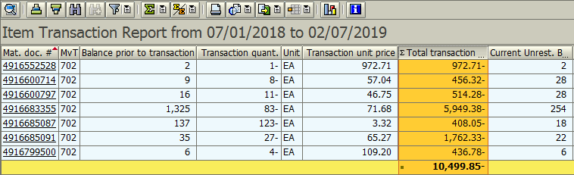

- Click the Exit icon once to begin the process for Line G.
- Inventory Transferred to/from another LEA - Open Transaction: ZMB20
- Line G mimics Line F with one exception Movement Types change from 702 to (303 & 304). If you have not exited ZMB20 you may go to Step c.

- Input the following as exhibited:
- Exception #1 – Change postings dates to: 07/01/2019; 06/30/2020
- Exception #2 - Change plant to your LEAs plant code.
- Click the Multiple Selection icon (Right-side of the right column)
A new window appears
Input the following as exhibited
When lower and upper limits keyed; click the “Exclude Single Values” Tab.
Input the following as exhibited
When the Exclude Single Value is keyed; click the execute icon in bottom left corner.
- This will return the software to the main ZMB20 screen.
- Input the following as exhibited:
- One Exception – Material Document Number will auto populate.
- Click the Execute icon (Upper left corner of the screen)
- If no transfers – the message “No data was found for selection criteria entered” appears. Enter zero for line G; otherwise continue with the steps.
A new window appears – Scroll to the right; click on the column header; Total Transaction Value
- The above action selects the entire column.
Click the Total icon - This will total the contents; scroll down to see the total and record the value within the Excel spreadsheet.
- The example below is only for a short span; it is merely a demonstration.
- Also, the example below is for Movement Type 701; at the time of this writing Movement Types 303 & 304 were not used in the LEA used for the examples.

- Click the Exit icon twice to return to the main menu.
- Removed Obsolete/Damaged Inventory
- Line H will flow automatically from the detailed accounting on the Obsolete Inventory Worksheet

Diesel Fuel Quantity & Value – (Charge Account code: 423)

Quick Computation Reference

 |  |  | Date |  | Material
Ln | Trans./Form | Col. | Range | Plant | Include | Exclude | Type | Total
A | TD-1 | -- | Prior Yr. | -- | -- | -- | -- | Line D
B | ZMB20 | Left | 07/01/2019 | 6### | 159000054 | -- | 971 | Total Trans. Quantity  & Value
 |  | Right | 06/30/2020 |  |  |  | 972
C | ZMB20 | Left | 07/01/2019 | 6### | 159000054 | -- | 261 | Total Trans. Quantity  & Value
 |  | Right | 06/30/2020 |  |  |  | 262
D | ZMB19 | Left | 12/2020 | 6### | 159000054 | -- | -- | Unrestricted Stock & Total  Value
 |  | Right | 12/2020
E | ZMB20 | Left | 07/01/2019 | 6### | 159000054 | -- | 701 | Total Trans. Quantity  & Value
 |  | Right | 06/30/2020
F | ZMB20 | Left | 07/01/2019 | 6### | 159000054 | -- | 702 | Total Trans. Quantity  & Value
 |  | Right | 06/30/2020
G | ZMB20 | Left | 07/01/2019 | 6### | 159000054 | -- | 303 | Total Trans. Quantity  & Value
 |  | Right | 06/30/2020 |  |  |  | 304
H | Obsolete Inv | -- | -- | -- | -- | -- | -- | Automatic
 | Worksheet

- Beginning Inventory
Two options to retrieve this information
- Option 1 – Prior year’s ZMB19 spreadsheet used to complete TD-1; or
- Option 2 – Prior year’s TD-1 Line D – Ending Actual Inventory

- Inventory Purchased - Open Transaction: ZMB20
- Input the following as exhibited:
- Exception #1 – Change postings dates to: 07/01/2019; 06/30/2020
- Exception #2 - Change plant to your LEAs plant code.
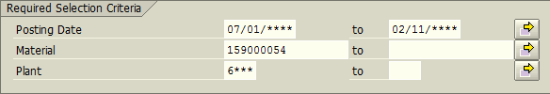
- Input the following as exhibited
- One Exception – Material Document Number will auto populate.
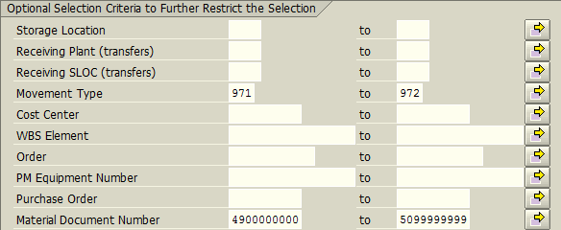
- Click the Execute icon (Upper left corner of the screen)
A new window appears – Scroll to the right; click on the column headers; Transaction Quantity and Total Transaction Value
- The above action selects the entire column.
Click the Total icon - This will total the contents of both columns; scroll down to see the total and record the value within the Excel spreadsheet.
- The example below is only for a few-months span; it is merely a demonstration.
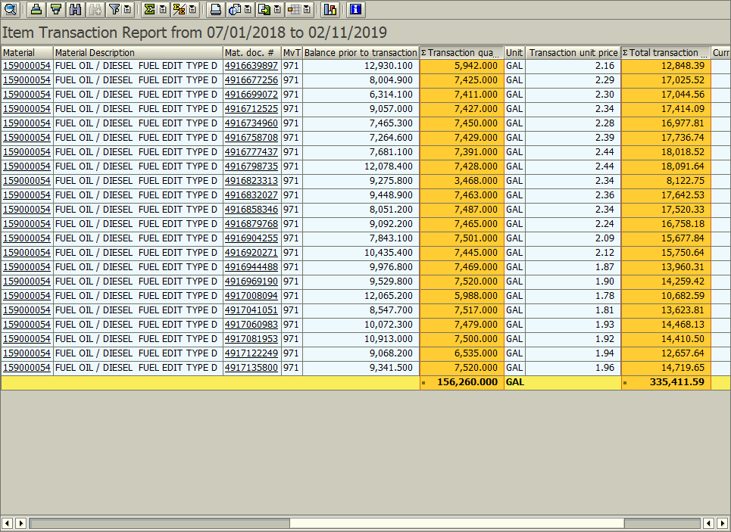

- Click the Exit icon once to begin the process for Line C.

- Inventory Used - Open Transaction: ZMB20
- Line C mimics Line B with one exception Movement Types change from (971 & 972 to (261 & 262). If you have not exited ZMB20 you may go to Step b.

- Input the following as exhibited:
- Exception #1 – Change postings dates to: 07/01/2019; 06/30/2020
- Exception #2 - Change plant to your LEAs plant code.
- Input the following as exhibited:
- One Exception – Material Document Number will auto populate.
- Click the Execute icon (Upper left corner of the screen)
A new window appears – Scroll to the right; click on the column header; Transaction Quantity & Total Transaction Value
- The above action selects the entire column.
Click the Total icon - This will total the contents of both columns; scroll down to see the total and record the value within the Excel spreadsheet.
- The example below is only for a short span; it is merely a demonstration.
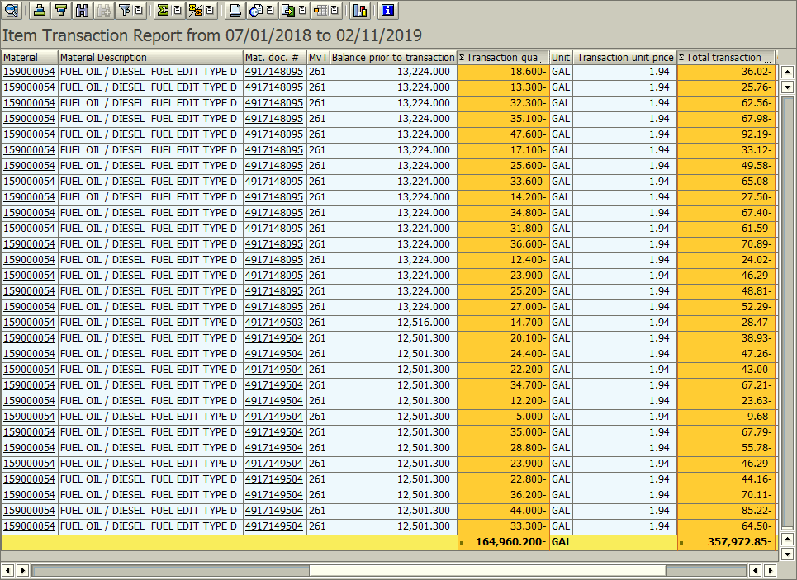

- Click the Exit icon twice to begin the process for Line D.
- Ending Inventory (Actual) - Open Transaction: ZMB19
- You must pull line D data on the last working day of June 2020 in the evening, or the first working day of July 2020 first thing in the morning.

- Input the following as exhibited:
- One Exception – Change plant to your LEAs plant code.
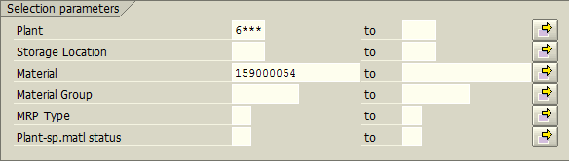
- Input the following as exhibited:
- Change the Period of Total usage to 12-2020 for both fields. Otherwise software will run slower.

- Click the Execute icon (Upper left corner of the screen)
A new window appears – Scroll to the right; click on the column headers; Unrestricted Use Stock and Total Value
- The above action selects the entire column.
Click the Total icon - This will total the contents; scroll down to see the total and record the value within the Excel spreadsheet.
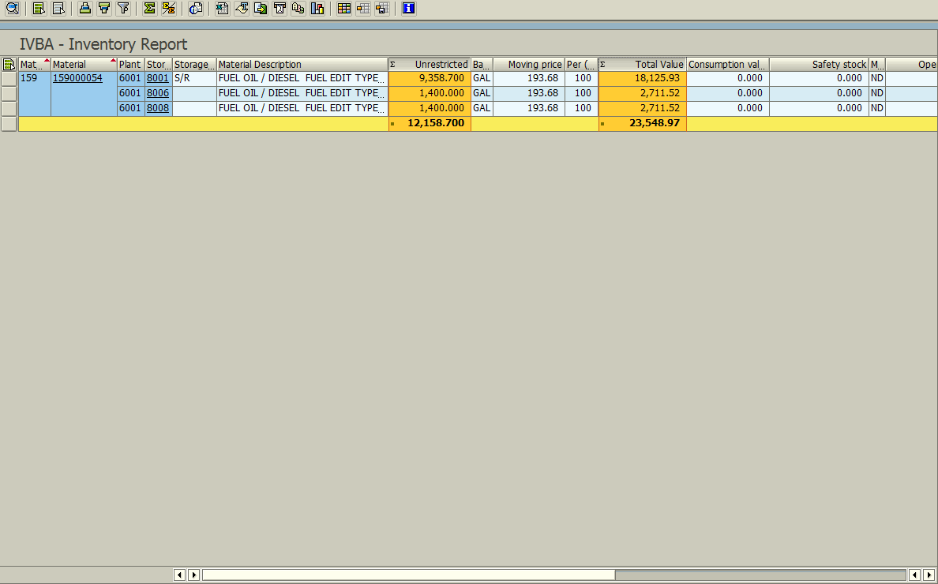

- Click the Exit icon twice to begin the process for Line E.

- Inventory Adjustments (Additions) - Open Transaction: ZMB20
- Line E mimics Line C with one exception Movement Types change from (261 & 262) to (701). If you have not exited ZMB20 you may go to Step c.

- Input the following as exhibited:
- Exception #1 – Change postings dates to: 07/01/2019; 06/30/2020
- Exception #2 - Change plant to your LEAs plant code.
- Input the following as exhibited:
- One Exception – Material Document Number will auto populate.

- Click the Execute icon (Upper left corner of the screen)
- If no adjustment – the message “No data was found for selection criteria entered” appears. Enter zero for line E; otherwise continue with the steps.
A new window appears – Scroll to the right; click on the column headers; Transaction Quantity and Total Transaction Value
- The above action selects the entire column.
Click the Total icon - This will total the contents of both columns; scroll down to see the total and record the value within the Excel spreadsheet.
- At the time of this writing, there is no image to demonstrate the totals.
- Click the Exit icon once to begin the process for Line F.

- Inventory Adjustments (Deletions) - Open Transaction: ZMB20
- Line F mimics Line E with one exception Movement Types change from 701 to 702. If you have not exited ZMB20 you may go to Step c.

- Input the following as exhibited:
- Exception #1 – Change postings dates to: 07/01/2019; 06/30/2020
- Exception #2 - Change plant to your LEAs plant code.
- Input the following as exhibited:
- One Exception - Material Document Number will auto populate.

- Click the Execute icon (Upper left corner of the screen)
- If no adjustment – the message “No data was found for selection criteria entered” appears. Enter zero for line F; otherwise continue with the steps.
A new window appears – Scroll to the right; click on the column headers; Transaction Quantity and Total Transaction Value
- The above action selects the entire column.
Click the Total icon - This will total the contents; scroll down to see the total and record the value within the Excel spreadsheet.
- At the time of this writing, there is no image to demonstrate the totals.
- Click the Exit icon once to begin the process for Line G.
- Inventory Transferred to/from another LEA - Open Transaction: ZMB20
- Line G mimics Line F with one exception Movement Types change from 702 to (303 & 304). If you have not exited ZMB20 you may go to Step C.

- Input the following as exhibited:
- Exception #1 – Change postings dates to: 07/01/2019; 06/30/2020
- Exception #2 - Change plant to your LEAs plant code.
- Input the following as exhibited:
- One Exception – Material Document Number will auto populate.
- Click the Execute icon (Upper left corner of the screen)
- If no transfers – the message “No data was found for selection criteria entered” appears. Enter zero for line G; otherwise continue with the steps.
A new window appears – Scroll to the right; click on the column headers; Transaction Quantity and Total Transaction Value
- The above action selects the entire column.
Click the Total icon - This will total the contents; scroll down to see the total and record the value within the Excel spreadsheet.
- At the time of this writing, there is no image to demonstrate the totals.
- Click the Exit icon once to begin the process for Line H.
- Removed Obsolete/Damaged Inventory
- Line H will flow automatically from the detailed accounting on the Obsolete Inventory Worksheet

Unleaded Fuel Quantity & Value – (Charge Account code: 423)

Quick Computation Reference

 |  |  | Date |  | Material
Ln | Trans./Form | Col. | Range | Plant | Include | Exclude | Type | Total
A | TD-1 | -- | Prior Yr. | -- | -- | -- | -- | Line D
B | ZMB20 | Left | 07/01/2019 | 6### | 159000055 | -- | 971 | Total Trans. Quantity  & Value
 |  | Right | 06/30/2020 |  |  |  | 972
C | ZMB20 | Left | 07/01/2019 | 6### | 159000055 | -- | 261 | Total Trans. Quantity  & Value
 |  | Right | 06/30/2020 |  |  |  | 262
D | ZMB19 | Left | 12/2020 | 6### | 159000055 | -- | -- | Unrestricted Stock & Total  Value
 |  | Right | 12/2020
E | ZMB20 | Left | 07/01/2019 | 6### | 159000055 | -- | 701 | Total Trans. Quantity  & Value
 |  | Right | 06/30/2020
F | ZMB20 | Left | 07/01/2019 | 6### | 159000055 | -- | 702 | Total Trans. Quantity  & Value
 |  | Right | 06/30/2020
G | ZMB20 | Left | 07/01/2019 | 6### | 159000055 | -- | 303 | Total Trans. Quantity  & Value
 |  | Right | 06/30/2020 |  |  |  | 304
H | Obsolete Inv | -- | -- | -- | -- | -- | -- | Automatic
 | Worksheet

- Beginning Inventory
Two options to retrieve this information
- Option 1 – Prior year’s ZMB19 spreadsheet used to complete TD-1; or
- Option 2 – Prior year’s TD-1 Line D – Ending Actual Inventory

- Inventory Purchased - Open Transaction: ZMB20
- Input the following as exhibited:
- Exception #1 – Change postings dates to: 07/01/2019; 06/30/2020
- Exception #2 - Change plant to your LEAs plant code.
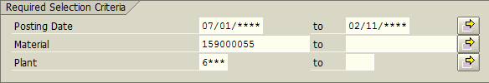
- Input the following as exhibited
- One Exception – Material Document Number will auto populate.

- Click the Execute icon (Upper left corner of the screen)
A new window appears – Scroll to the right; click on the column header; Transaction Quantity and Total Transaction Value
- The above action selects the entire column.
Click the Total icon - This will total the contents of both columns; scroll down to see the total and record the value within the Excel spreadsheet.
- The example below is only for a few-months span; it is merely a demonstration.
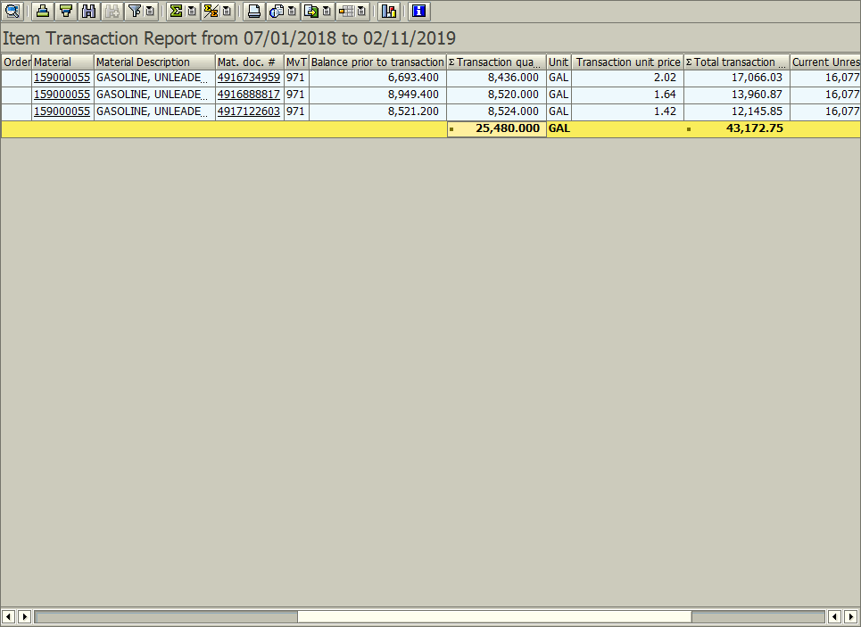

- Click the Exit icon once to begin the process for Line C.

- Inventory Used - Open Transaction: ZMB20
- Line C mimics Line B with one exception Movement Types change from (971 & 972 to (261 & 262). If you have not exited ZMB20 you may go to Step b.

- Input the following as exhibited:
- Exception #1 – Change postings dates to: 07/01/2019; 06/30/2020
- Exception #2 - Change plant to your LEAs plant code.
- Input the following as exhibited:
- One Exception – Material Document Number will auto populate.

- Click the Execute icon (Upper left corner of the screen)
A new window appears – Scroll to the right; click on the column headers; Transaction Quantity & Total Transaction Value
- The above action selects the entire column.
Click the Total icon - This will total the contents of both columns; scroll down to see the total and record the value within the Excel spreadsheet.
- The example below is only for a short span; it is merely a demonstration.
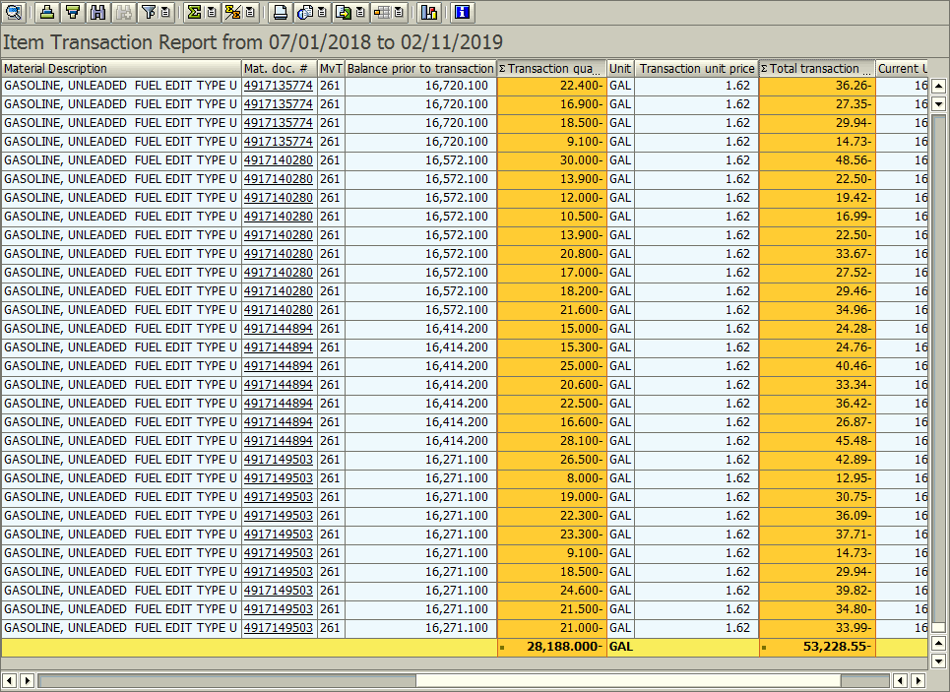

- Click the Exit icon twice to begin the process for Line D.
- Ending Inventory (Actual) - Open Transaction: ZMB19
- You must pull line D data on the last working day of June 2020 in the evening, or the first working day of July 2020 first thing in the morning.

- Input the following as exhibited:
- One Exception – Change plant to your LEAs plant code.
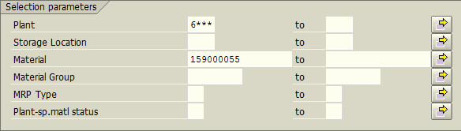
- Input the following as exhibited:
- Change the Period of Total usage to 12-2020 for both fields. Otherwise software will run slower.
- Click the Execute icon (Upper left corner of the screen)
A new window appears – Scroll to the right; click on the column headers; Unrestricted Use Stock and Total Value
- The above action selects the entire column.
Click the Total icon - This will total the contents; scroll down to see the total and record the value within the Excel spreadsheet.
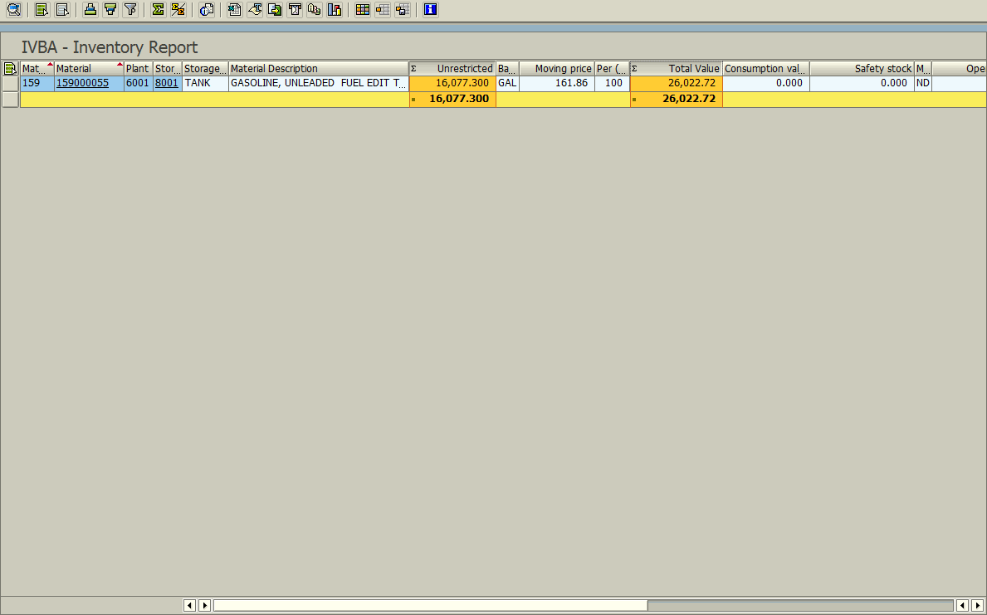

- Click the Exit icon twice to begin the process for Line E.

- Inventory Adjustments (Additions) - Open Transaction: ZMB20
- Line E mimics Line C with one exception Movement Types change from (261 & 262) to (701). If you have not exited ZMB20 you may go to Step c.

- Input the following as exhibited:
- Exception #1 – Change postings dates to: 07/01/2019; 06/30/2020
- Exception #2 - Change plant to your LEAs plant code.
- Input the following as exhibited:
- One Exception – Material Document Number will auto populate.
- Click the Execute icon (Upper left corner of the screen)
- If no adjustment – the message “No data was found for selection criteria entered” appears. Enter zero for line E; otherwise continue with the steps.
A new window appears – Scroll to the right; click on the column headers; Transaction Quantity and Total Transaction Value
- The above action selects the entire column.
Click the Total icon - This will total the contents of both columns; scroll down to see the total and record the value within the Excel spreadsheet.
- At the time of this writing, there is no image to demonstrate the totals.
- Click the Exit icon once to begin the process for Line F.
- Inventory Adjustments (Deletions) - Open Transaction: ZMB20
- Line F mimics Line E with one exception Movement Types change from 701 to 702. If you have not exited ZMB20 you may go to Step c.

- Input the following as exhibited:
- Exception #1 – Change postings dates to: 07/01/2019; 06/30/2020
- Exception #2 - Change plant to your LEAs plant code.
- Input the following as exhibited:
- One Exception - Material Document Number will auto populate.
- Click the Execute icon (Upper left corner of the screen)
- If no adjustment – the message “No data was found for selection criteria entered” appears. Enter zero for line F; otherwise continue with the steps.
A new window appears – Scroll to the right; click on the column headers; Transaction Quantity and Total Transaction Value
- The above action selects the entire column.
Click the Total icon - This will total the contents; scroll down to see the total and record the value within the Excel spreadsheet.
- At the time of this writing, there is no image to demonstrate the totals.
- Click the Exit icon once to begin the process for Line G.
- Inventory Transferred to/from another LEA - Open Transaction: ZMB20
- Line G mimics Line F with one exception Movement Types change from 702 to (303 & 304). If you have not exited ZMB20 you may go to Step C.

- Input the following as exhibited:
- Exception #1 – Change postings dates to: 07/01/2019; 06/30/2020
- Exception #2 - Change plant to your LEAs plant code.
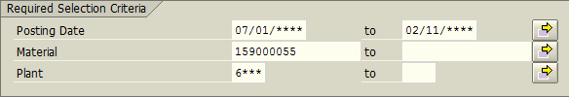
- Input the following as exhibited:
- One Exception – Material Document Number will auto populate.
- Click the Execute icon (Upper left corner of the screen)
- If no transfers – the message “No data was found for selection criteria entered” appears. Enter zero for line G; otherwise continue with the steps.
A new window appears – Scroll to the right; click on the column headers; Transaction Quantity and Total Transaction Value
- The above action selects the entire column.
Click the Total icon - This will total the contents; scroll down to see the total and record the value within the Excel spreadsheet.
- At the time of this writing, there is no image to demonstrate the totals.
- Click the Exit icon twice to return to main menu.
- Removed Obsolete/Damaged Inventory
- Line H will flow automatically from the detailed accounting on the Obsolete Inventory Worksheet

Other Fuels and DEF – (Charge Account code: 423)

Quick Computation Reference
 |  |  | Date |  | Material
Ln | Trans./Form | Col. | Range | Plant | Include | Exclude | Type | Total
A | TD-1 | -- | Prior Yr. | -- | -- | -- | -- | Line D
B | ZMB20 | Left | 07/01/2019 | 6### | 159000056 | -- | 101 | Total Trans. Value
 |  | Right | 06/30/2020 |  | 159000062 |  | 199
 |  | Left |  |  | 159000052 |  | 971
 |  | Right |  |  | 159000053 |  | 972
 |  | Left |  |  | 159000098
 |  | Right |  |  | 159000099
C | ZMB20 | Left | 07/01/2019 | 6### | 159000056 | -- | 261 | Total Trans. Value
 |  | Right | 06/30/2020 |  | 159000062 |  | 262
 |  | Left |  |  | 159000052
 |  | Right |  |  | 159000053
 |  | Left |  |  | 159000098
 |  | Right |  |  | 159000099
D | ZMB19 | Left | 12/2020 | 6### | 159000056 | -- | -- | Total Value
 |  | Right | 12/2020 |  | 159000062
 |  | Left |  |  | 159000052
 |  | Right |  |  | 159000053
 |  | Left |  |  | 159000098
 |  | Right |  |  | 159000099
E | ZMB20 | Left | 07/01/2019 | 6### | 159000056 | -- | 701 | Total Trans. Value
 |  | Right | 06/30/2020 |  | 159000062
 |  | Left |  |  | 159000052
 |  | Right |  |  | 159000053
 |  | Left |  |  | 159000098
 |  | Right |  |  | 159000099
F | ZMB20 | Left | 07/01/2019 | 6### | 159000056 | -- | 702 | Total Trans. Value
 |  | Right | 06/30/2020 |  | 159000062
 |  | Left |  |  | 159000052
 |  | Right |  |  | 159000053
 |  | Left |  |  | 159000098
 |  | Right |  |  | 159000099
G | ZMB20 | Left | 07/01/2019 | 6### | 159000056 | -- | 303 | Total Trans. Value
 |  | Right | 06/30/2020 |  | 159000062 |  | 304
 |  | Left |  |  | 159000052
 |  | Right |  |  | 159000053
 |  | Left |  |  | 159000098
 |  | Right |  |  | 159000099
H | Obsolete Inv | -- | -- | -- | -- | -- | -- | Automatic
 | Worksheet

- Beginning Inventory
Two options to retrieve this information
- Option 1 – Prior year’s ZMB19 spreadsheet used to complete TD-1; or
- Option 2 – Prior year’s TD-1 Line D – Ending Actual Inventory

- Inventory Purchased - Open Transaction: ZMB20
- Input the following as exhibited:
- Exception #1 – Change postings dates to: 07/01/2019; 06/30/2020
- Exception #2 – Change plant to your LEAs plant code.
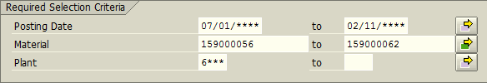
- Click the Multiple Selection icon (Right-side of the right column)
A new window appears
Input the following as exhibited.
When lower and upper limits keyed; click the execute icon in bottom left corner.
- This will return the software to the main ZMB20 screen.
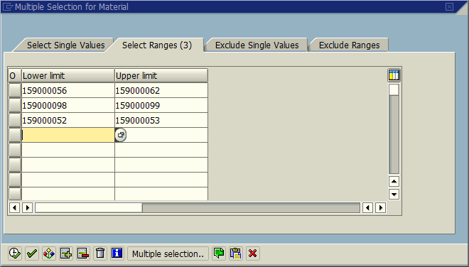

- Input the following as exhibited:
- One Exception – Material Document Number will auto populate.
- Click the Multiple Selection icon (Right-side of the right column)
A new window appears
Input the following as exhibited.
When lower and upper limits keyed; click the execute icon in bottom left corner.
- This will return the software to the main ZMB20 screen.
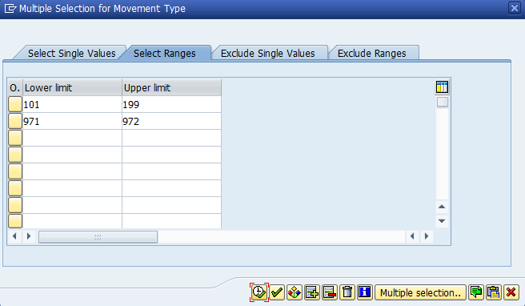
- Click the Execute icon (Upper left corner of the screen)
A new window appears – Scroll to the right; click on the column header; Total Transaction Value
- The above action selects the entire column.
Click the Total icon - This will total the contents; scroll down to see the total and record the value within the Excel spreadsheet.
- The example below is only for a one-month span; it is merely a demonstration.
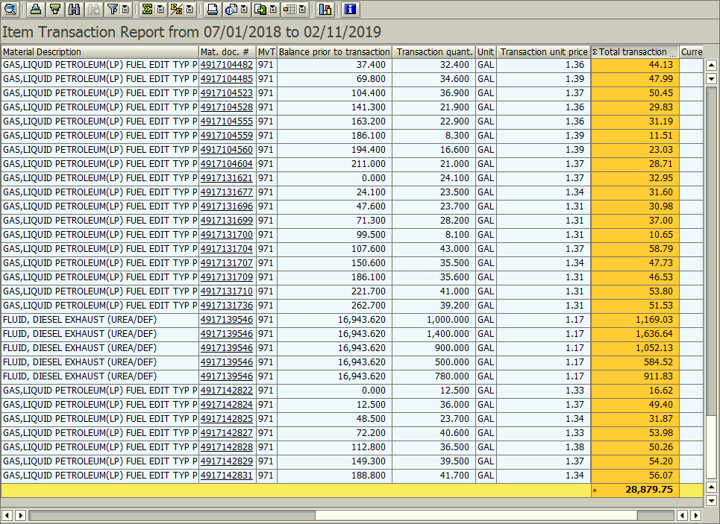

- Click the Exit icon once to begin the process for Line C.

- Inventory Used - Open Transaction: ZMB20
- Line C mimics Line B with one exception Movement Types change from (101 & 199; 971 & 972) to (261 & 262). If you have not exited ZMB20 you may go to Step c.

- Input the following as exhibited:
- Exception #1 – Change postings dates to: 07/01/2019; 06/30/2020
- Exception #2 – Change plant to your LEAs plant code.
- Click the Multiple Selection icon (Right-side of the right column)
A new window appears
Input the following as exhibited. When lower and upper limits keyed; click the execute icon in bottom left corner.
- This will return the software to the main ZMB20 screen.
- Input the following as exhibited:
- One Exception – Material Document Number will auto populate.
- Click the Execute icon (Upper left corner of the screen)
A new window appears – Scroll to the right; click on the column header; Total Transaction Value
- The above action selects the entire column.
Click the Total icon - This will total the contents; scroll down to see the total and record the value within the Excel spreadsheet.
- The example below is only for a one-month span; it is merely a demonstration.
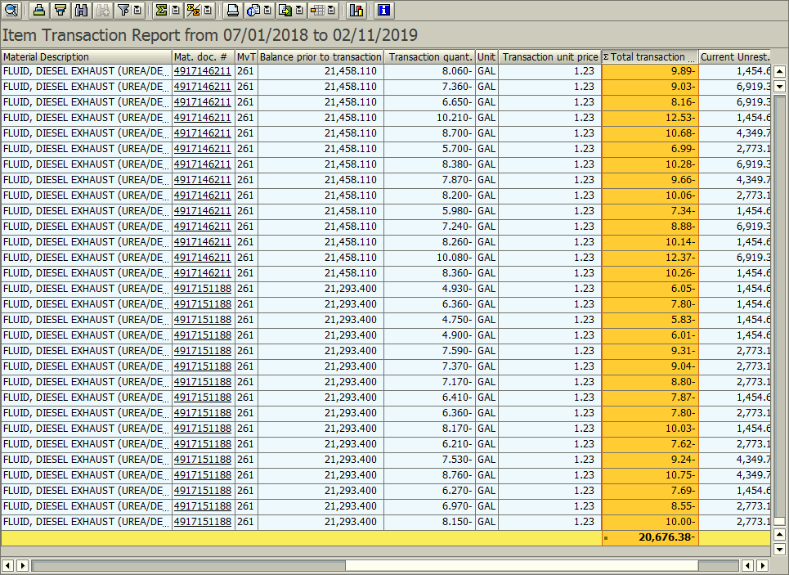

- Click the Exit icon twice to begin the process for Line D.
- Ending Inventory (Actual) - Open Transaction: ZMB19
- You must pull line D data on the last working day of June 2020 in the evening, or the first working day of July 2020 first thing in the morning.

- Input the following as exhibited:
- One Exception – Change plant to your LEAs plant code.
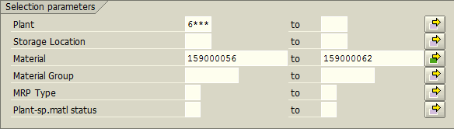
- Click the Multiple Selection icon (Right-side of the right column)
A new window appears
Input the following as exhibited. When lower and upper limits keyed; click the execute icon in bottom left corner.
- This will return the software to the main ZMB19 screen.
- Input the following as exhibited:
- Change the Period of Total usage to 12/2020 for both fields. Otherwise software will run slower. 2019
- Click the Execute icon (Upper left corner of the screen)
A new window appears – Scroll to the right; click on the column header; Total Value
- The above action selects the entire column.
Click the Total icon - This will total the contents; scroll down to see the total and record the value within the Excel spreadsheet.
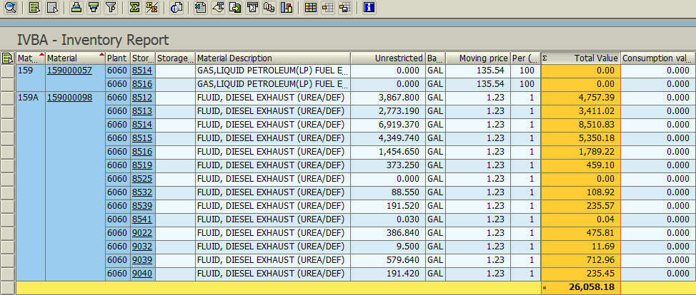

- Click the Exit icon twice to begin the process for Line E.

- Inventory Adjustments (Additions) - Open Transaction: ZMB20
- Line E mimics Line C with one exception Movement Types change from (261 & 262) to (701). If you have not exited ZMB20 you may go to Step c.

- Input the following as exhibited:
- Exception #1 – Change postings dates to: 07/01/2019; 06/30/2020
- Exception #2 – Change plant to your LEAs plant code.
- Click the Multiple Selection icon (Right-side of the right column)
A new window appears
Input the following as exhibited.
When lower and upper limits keyed; click the execute icon in bottom left corner.
- This will return the software to the main ZMB20 screen.
- Input the following as exhibited:
- One Exception – Material Document Number will auto populate.
- Click the Execute icon (Upper left corner of the screen)
- If no adjustment – the message “No data was found for selection criteria entered” appears. Enter zero for line E; otherwise continue with the steps.
A new window appears – Scroll to the right; click on the column header; Total Transaction Value
- The above action selects the entire column.
Click the Total icon - This will total the contents; scroll down to see the total and record the value within the Excel spreadsheet.
- The example below is only for a shortened span; it is merely a demonstration.
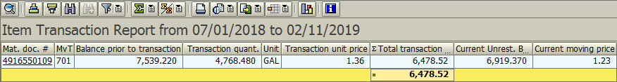

- Click the Exit icon once to begin the process for Line F.
- Inventory Adjustments (Deletions) - Open Transaction: ZMB20
- Line F mimics Line E with one exception Movement Types change from 701 to 702. If you have not exited ZMB20 you may go to Step c.

- Input the following as exhibited:
- Exception #1 – Change postings dates to: 07/01/2019; 06/30/2020
- Exception #2 – Change plant to your LEAs plant code.
- Click the Multiple Selection icon (Right-side of the right column)
A new window appears
Input the following as exhibited. When lower and upper limits keyed; click the execute icon in bottom left corner.
- This will return the software to the main ZMB20 screen.
- Input the following as exhibited:
- One Exception – Material Document Number will auto populate.
- Click the Execute icon (Upper left corner of the screen)
- If no adjustment – the message “No data was found for selection criteria entered” appears. Enter zero for line F; otherwise continue with the steps.
A new window appears – Scroll to the right; click on the column header; Total Transaction Value
- The above action selects the entire column.
Click the Total icon - This will total the contents; scroll down to see the total and record the value within the Excel spreadsheet.
- At the time of this writing, there is no image to demonstrate the totals.
- Click the Exit icon once to begin the process for Line G.
- Inventory Transferred to/from another LEA - Open Transaction: ZMB20
- Line G mimics Line F with one exception Movement Types change from 702 to (303 & 304). If you have not exited ZMB20 you may go to Step c.

- Input the following as exhibited:
- Exception #1 – Change postings dates to: 07/01/2019; 06/30/2020
- Exception #2 – Change plant to your LEAs plant code.
- Click the Multiple Selection icon (Right-side of the right column)
A new window appears
Input the following as exhibited.
When lower and upper limits keyed; click the execute icon in bottom left corner.
- This will return the software to the main ZMB20 screen.
- Input the following as exhibited:
- One Exception – Material Document Number will auto populate.
- Click the Execute icon (Upper left corner of the screen)
- If no transfers – the message “No data was found for selection criteria entered” appears. Enter zero for line G; otherwise continue with the steps.
A new window appears – Scroll to the right; click on the column header; Total Transaction Value
- The above action selects the entire column.
Click the Total icon - This will total the contents; scroll down to see the total and record the value within the Excel spreadsheet.
- At the time of this writing, there is no image to demonstrate the totals.
- Click the Exit icon twice to return to main menu.
- Removed Obsolete/Damaged Inventory
- Line H will flow automatically from the detailed accounting on the Obsolete Inventory Worksheet.

Non-Stock Inventory – Data Entry

BSIP Transactions Utilities Required
- ZMB36 – Inventory query: IVBA

Icons Used in Transactions

- Multiple Selection icon
- Execute icon
- Total icon
- Exit icon

Non-Stock Inventory Purchased and Used This Year

- Non-Stock Inventory Purchased - Open Transaction: ZMB36B
- Input the following as exhibited:
- Exception #1 – Change postings dates to: 07/01/2019; 06/30/2020
- Exception #2 – Change plant to your LEAs plant code.
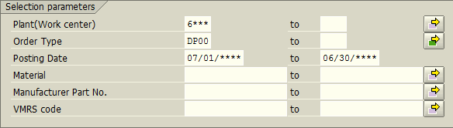
- Click the Execute icon (Upper left corner of the screen)
A new window appears – Scroll to the right; record the totals that are displayed on the top line.
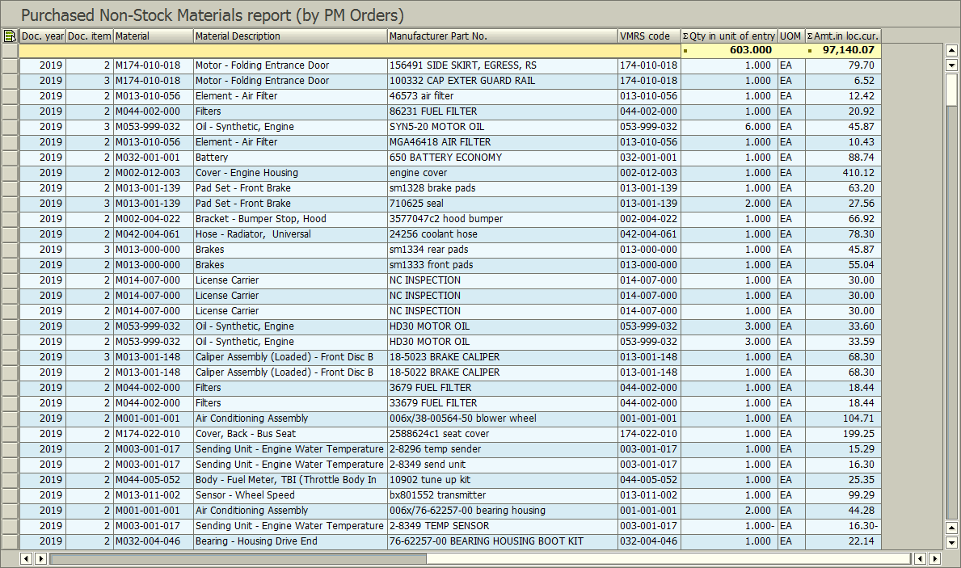

- Click the Exit icon to return to main menu.
Obsolete or Damaged Inventory – Data Entry

- Obsolete or Damaged Inventory - Open Transaction: ZMB20
- Input the following as exhibited:
- Exception #1 – Change postings dates to: 07/01/2019; 06/30/2020
- Exception #2 – Change plant to your LEAs plant code.
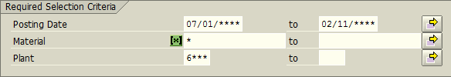
- Input the following as exhibited:
- One Exception – Material Document Number will auto populate.
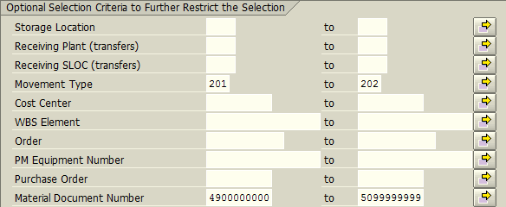

- Click the Execute icon (Upper left corner of the screen)
- If no obsolete or damaged inventory – the message “No data was found for selection criteria entered” appears. Enter nothing; otherwise continue with the steps.
A new window appears – Use the report that appears to complete the required fields on the spreadsheet.
- The example below is only for a shortened span; it is merely a demonstration.
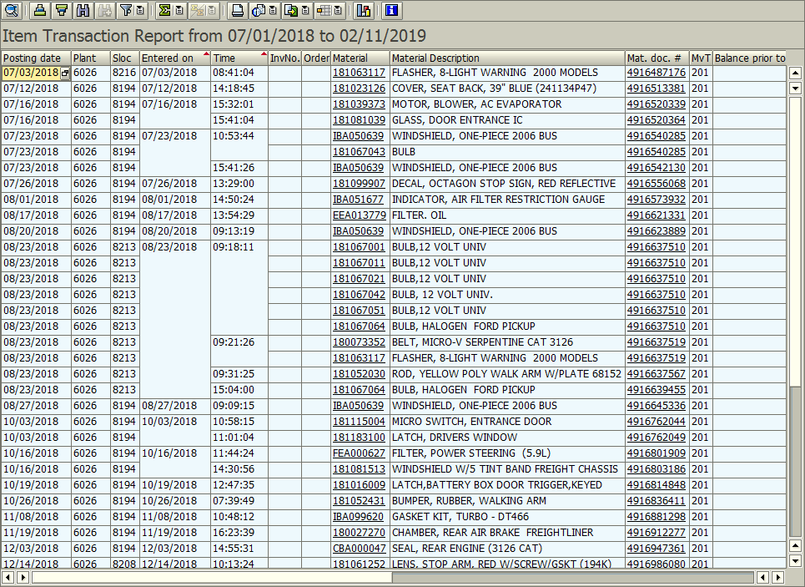

- Click the Exit icon twice to return to the main menu
Buster Report – Data Entry

- Data Entry
- Did not share or own a Buster Bus
On the Excel Worksheet titled “Buster Report” click on the box at the end of the line “Check if LEA does not own/share a Buster Robotic Bus.” Report is complete.
- Share or own a Buster Bus
  - Date
Enter the date a demonstration of Buster was implemented. Format mm-dd-yyyy.
  - Time
Enter time in total hours. Round to the nearest ½ hour. (Example: 1.5)
  - Local
Enter the name of the school or if a public demonstration the name of local (Example: County Fair).
  - Individuals Present
Give as best as possible a rough estimate of the number of individuals who viewed the demonstration.
  - Check all that apply
Indicate to whom the demonstration was for by selecting the appropriate check box fields.

